Newcastle, 2024
Stuart Warren Research Assistant: DETERMIND
DETERMIND participants Day

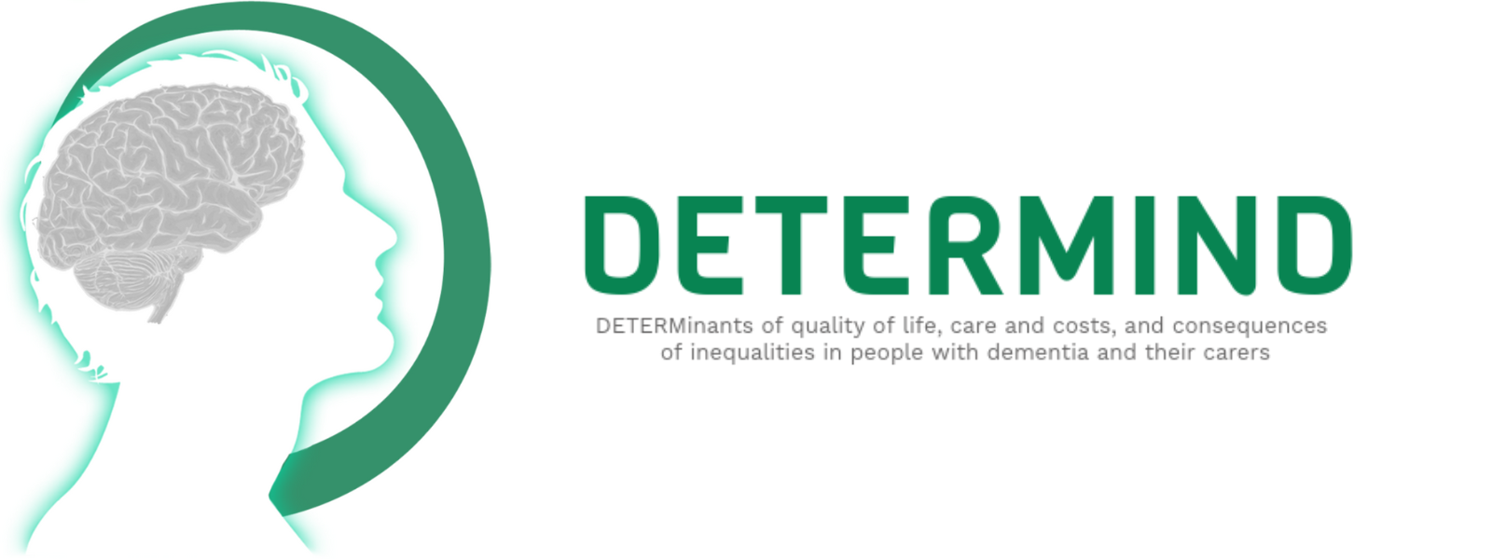
Contents
Introduction 2
About DETERMIND & The Project So Far 3
The Future of DETERMIND 4
Future Events – London 4
Participants Update Day, Newcastle 5
Feedback 6
Bo Hu: Use of health and social care among people living with dementia 7
The selective usage of health and social care 9
Key Findings and Summary 16
John Hammond: Using the Candidacy Framework to explore the experiences of LGB+ PLWD 17
“It hasn’t always been rainbows and giggles.” 17
“It’s important that you’re here and we’re being recognised.” 19
Key Findings and Reflections 22
Kate Gridley – The Experiences of People Who Pay for Care: Social Snake and Ladders 23
The Absence of Formal Support 23
Navigation Capital 24
Care Planning 25
Useful Resources 26
Ríona McArdle - Staying physically active with dementia: Early insights from the ActivDem x DETERMIND studies 28
What does Physical Activity look like in Dementia? 29
Early Insights from ActivDem 30
Ben Hicks – Early vs Timely Diagnosis: Unravelling the Best Approach 33
An Introduction to Timely Diagnosis 33
Key Findings 33

Introduction
As we approach the planned end date of the project, the team thought it would be beneficial to update the participants on the study's progress and highlight our future aims. As many of you know, the DETERMIND is the largest dementia care research project running in England, provided as a multi-institutional study that aims to reduce inequalities and improve access to care.
First, we would like to start with some Thank Yous!
Thank You to the participants who devoted their time to the study. Without the support of people living with dementia and their Caregivers, we would not have been able to conduct such a critical study. We hope that regardless of where the future lies, we have brought your experiences forward to change how we provide services. Thank you to the participants who joined in person or online in Newcastle in June 2024. Thank you to the Gateshead team for arranging the event, making us feel so welcome, and arranging such a fantastic buffet for lunch.
For those who joined us in Newcastle, the participant day was your opportunity to meet the team, have a delicious lunch, pass on your comments, and get updated on what we have managed to achieve over the last five years. Our guest speakers provided an information-packed day; we have produced some highlights below.
You can learn more about our project, the researchers, and current findings by clicking on our website, DETERMIND


About DETERMIND & The Project So Far
DETERMIND is an ambitious national project funded by the Economic and Social Research Council, led by multi-institutional researchers from teams across England. It aims to assess the lived experience of participants within six months of receiving a dementia diagnosis. Dementia is one of the most common and severe threats society faces, with more than 800,000 people affected in the UK. The impact of a diagnosis can be devastating for the person living with dementia and their families. Our project set out to address some of the unanswered questions about the impact of gaining a diagnosis, the quality of the care provided, and the impact a diagnosis can have on well-being and quality of life. DETERMIND aims to identify and address some of these inequalities, improving the services provided and making those services more accessible to all.
The project has six main aims or workstreams.
- To recruit 900 PLWD and their Caregivers to follow their progress over three years after a diagnosis.
- Investigate the inequalities and barriers to dementia care and work towards improving access to care.
- Compare the usage and costs of dementia services and their outcomes.
- Compare the outcomes of those who can fund their care and those who cannot.
- Investigate how PLWD and their carers make decisions
- Compare the impact of the timeliness of a diagnosis.
Over time, the project has evolved, and we have been delighted to add sub-studies, including the COVID-19 DETERMIND Sub-Study and ActivDem. The Covid sub-study aims to assess the impact of gaining a dementia diagnosis during the pandemic, the impact of the pandemic on well-being and quality of life for PLWD, and their access to care during lockdown. ActivDem aims to assess the effects of physical activity on the well-being of PLWD. Both studies aim to highlight further the challenges faced by the dementia community and improve access to services.
At this exciting juncture, we are pleased to announce that we have closed the COVID-19 sub-study and completed the Time 2 points for DETERMIND. We are working hard to analyse the data and will contact you soon with our findings.

The Future of DETERMIND
DETERMIND has been an ambitious project that has far exceeded the expectations of those involved. Our funding was set to last until December 2024. However, we are not quite ready for the study to end. The team has been working hard to ensure that your voices continually shape how we provide care to PLWD and their Caregivers after they receive a diagnosis. We have one of the most significant samples in England, and we are working on new funding opportunities to extend the project for another couple of years. In June 2024, we submitted a bid for funding, and we are hopeful that we will be able to secure financing to continue the project. We hope to provide an update in November 2024 and will let you know if we have gotten through to the next round of the funding process.

Future Events – London
To celebrate the project's success, we invite participants to join us in London to thank them for participating. When we confirm the venue and the date, we will contact you to invite you.








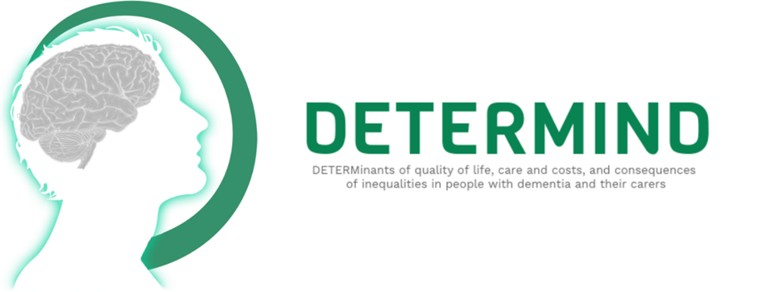
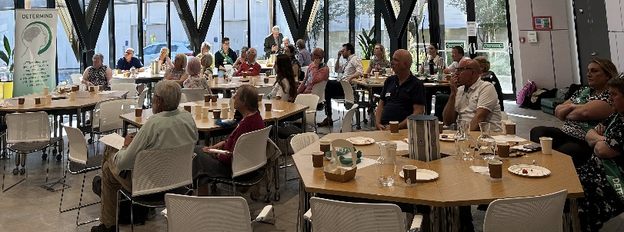

The PResenters
- Bo Hu: Use of health and social care among people living with dementia
- John Hammond: Using the Candidacy Framework to explore the experiences of lesbian, gay and bisexual people living with dementia
- Kate Gridley – The Experiences of People Who Pay for Care: Social Snake and Ladders.
- Ríona McArdle - Staying physically active with dementia: Early insights from the ActivDem x DETERMIND studies
- Ben Hicks – Early vs Timely Diagnosis: Unravelling the Best Approach
Our 2024 event was hosted by the Gateshead Team, within the catalyst at Newcastle University. Over thirty couples joined us for some lunch, a chance to catch up on our progress and provide feedback to their involvement in the project.
We were able to thank everyone for their hard work in making our project a success!
DETERMIND is an ambitious national project funded by the Economic and Social Research Council, led by researchers from teams across England. It aims to assess the lived experience of participants and their carers after they get a dementia diagnosis. Dementia is one of the most common and serious threats society faces, with more than 800,000 people affected in the UK. The impact of a diagnosis can be devastating for the person living with dementia (PLWD), their families and the communities they belong to. Our project has set out to address some of the unanswered questions about the impact of gaining a diagnosis, the quality of the care provided and the impact a diagnosis can have on well-being and quality of life. DETERMIND aims to identify and address some of these inequalities, improving the services provided and making those services more accessible to all.
DETERMIND Participants Conference 2024

Participants Update Day, Newcastle
We were hosted at the Catalyst in Newcastle University by the Gateshead team and were joined by PLWD and their carers from Newcastle. Those who could not join us in person were given a link to join online. Participants met with the team, provided feedback about the project, and were updated on the project's aims and progress. Our guest speakers on the project's workstreams presented an exciting look at what we know about the provision of dementia care and why you would have been asked specific questions during your DETERMIND interviews.
Our guest speakers were -
- Bo Hu From the Care Policy and Evaluation Centre (CPEC) of the London School of Economics and Political Science. Bo led the day by discussing health and social care inequalities and how PLWD and its carers can have difficulties accessing services, highlighting the importance of making these services more accessible.
- John Hammond from the Brighton and Sussex Medical School Celebrated Pride Month and gave us a brief history of the LGBT+ community, highlighting the specific challenges older LGBT+ adults can face while accessing services and discussing how the candidacy framework can help to identify the particular challenges faced by the LBGT+ community while accessing health and social care.
- Kate Gridley from York University discussed the barriers that self-funders face when accessing local authority social care and how participants can navigate social care using ‘navigation capital.’
- Ríona McArdle from Newcastle University discussed the importance of activity within older adults and PLWD and introduced the ActivDem study. Understanding activity levels within older adults can help us shape how we live PLWD live healthier lifestyles after gaining a dementia diagnosis.
- Ben Hicks from the Brighton and Sussex Medical School closed the day by discussing how the timeliness of a diagnosis can help PLWD plan for their future and put in place, at an early stage, the health or social support they may require as the dementia progresses.
We have included detailed information about each presentation, including ease-of-access information sheets to catch up on the day's events. If you have any questions or comments, please get in touch with the team; we can answer them!
To all who could attend in person or online, thank you for making the day a success! For those who could not, we look forward to welcoming you to our next event.

Feedback
We value the effort and work our participants have put into our project. If you have any feedback on the project or would like to share your experiences, don't hesitate to contact the DETERMIND team at DETERMIND@bsms.ac.uk.

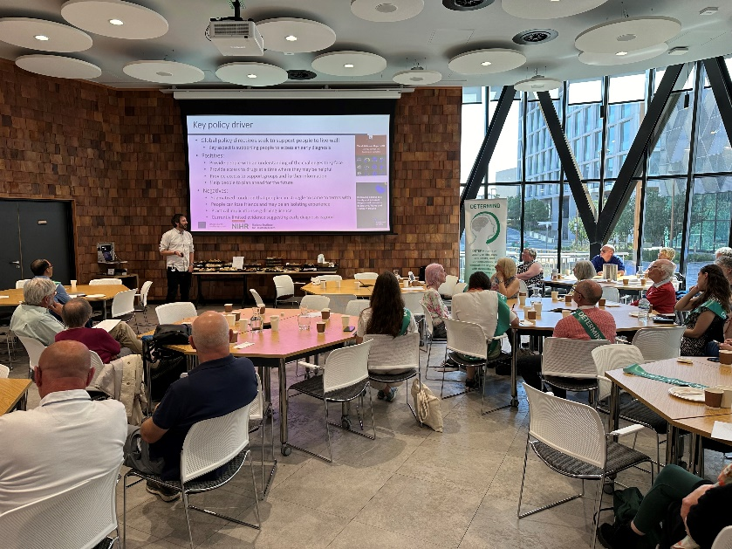
Photographs of the Day
Ben Hicks leads the day with an introduction to DETERMIND
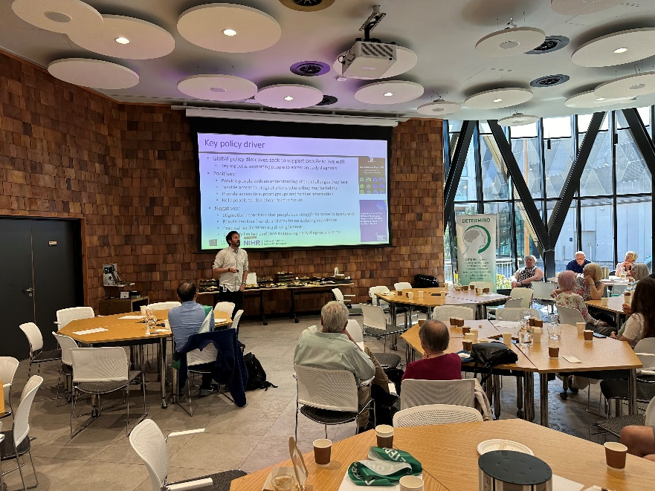
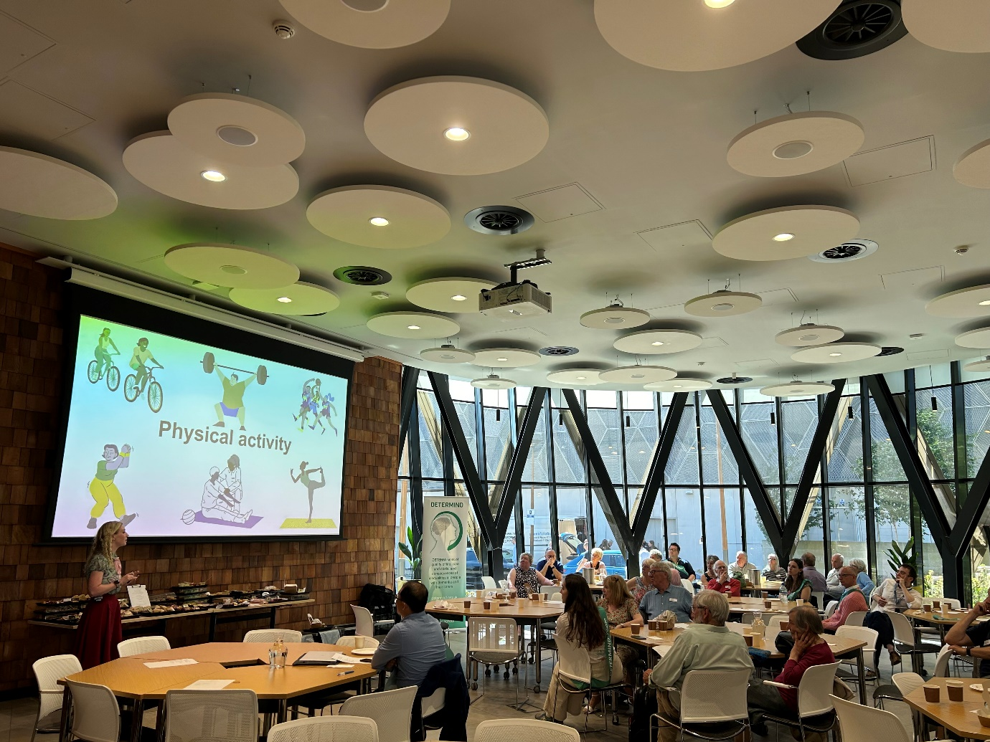
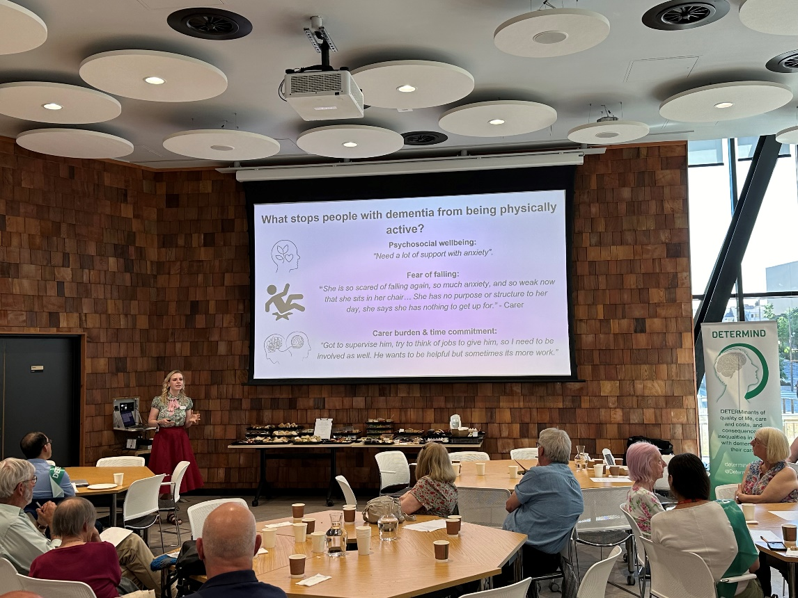
Ríona McArdle on ActivDem
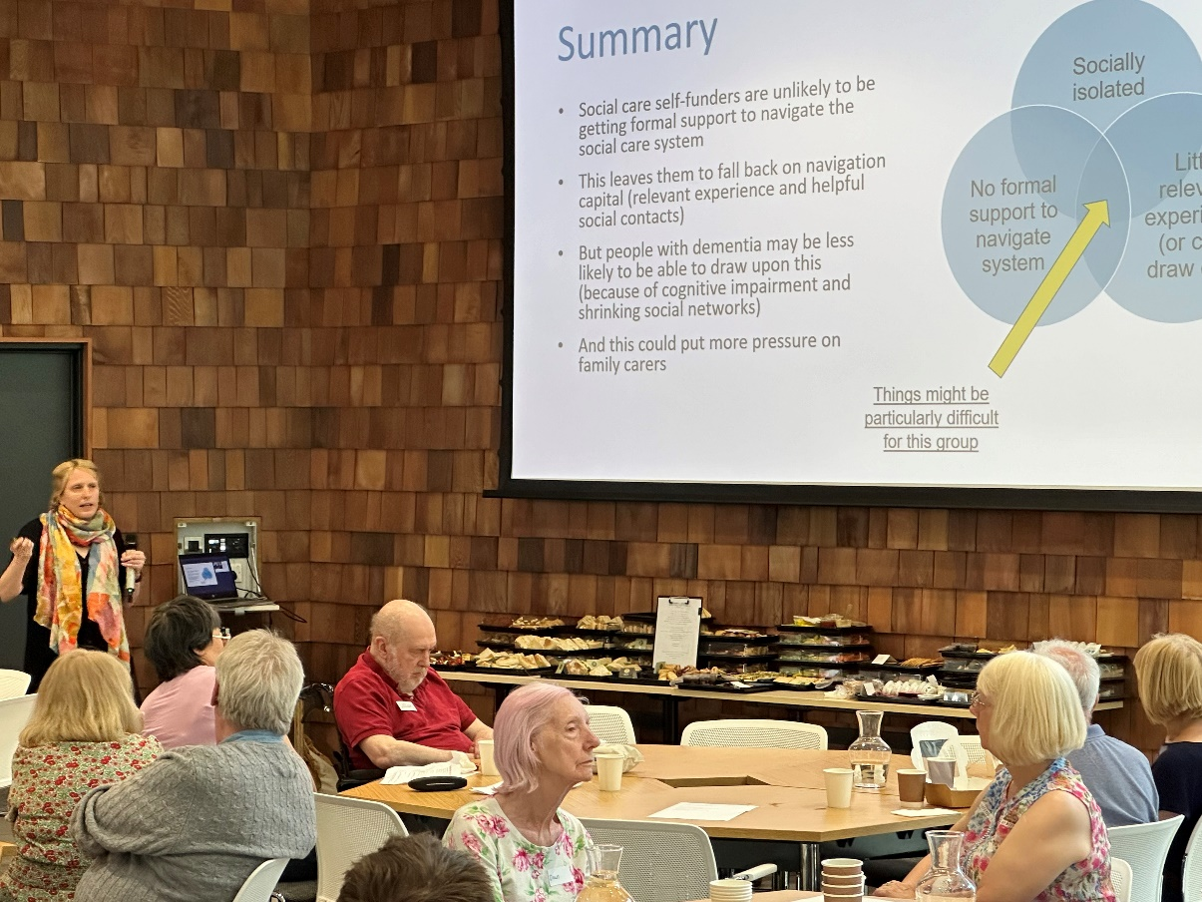
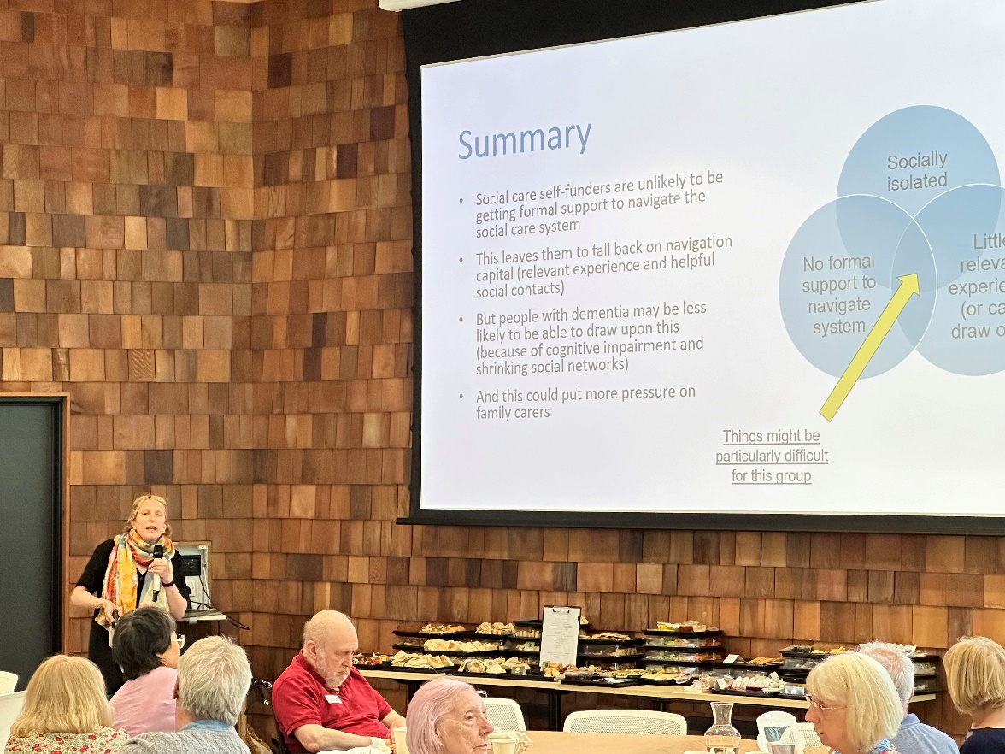
Kate Gridley Discusses access to Adult Social Care
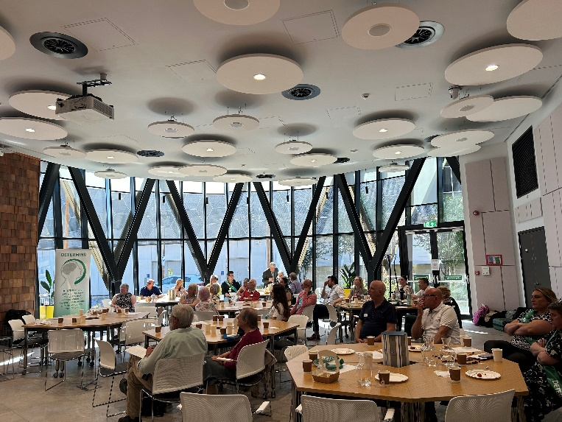
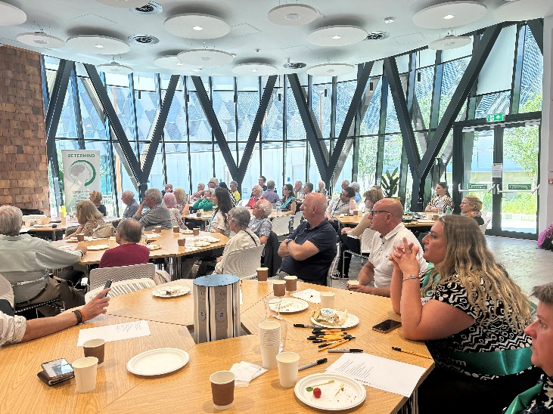
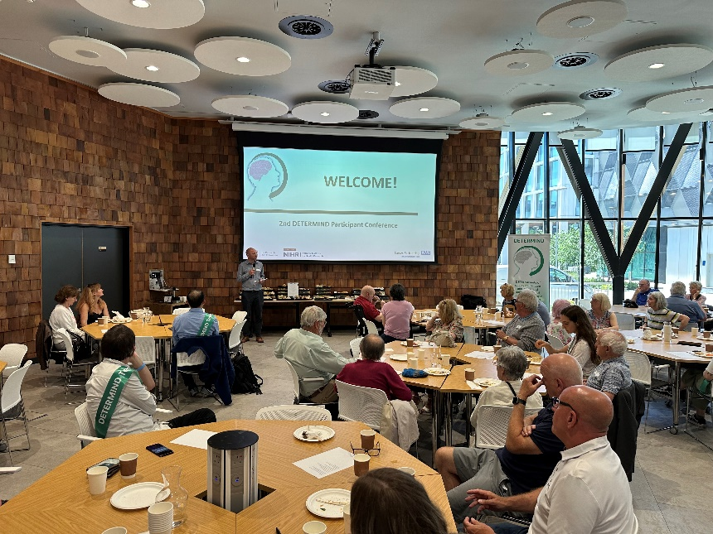
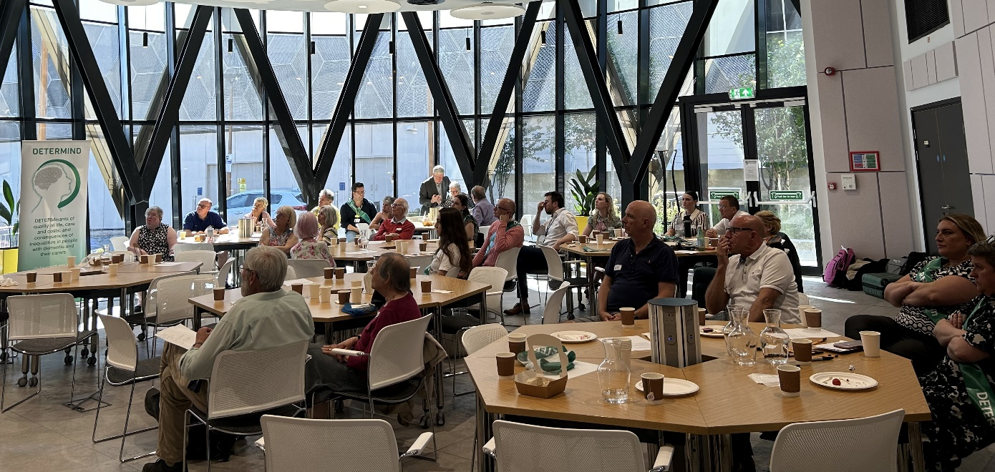
Some pictures of our participants during the presentations.
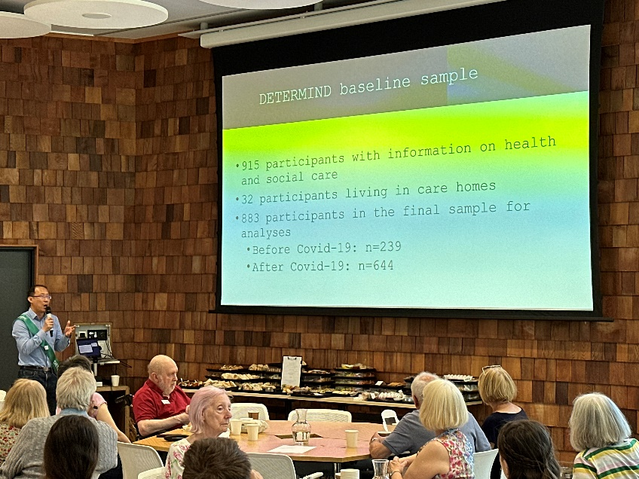
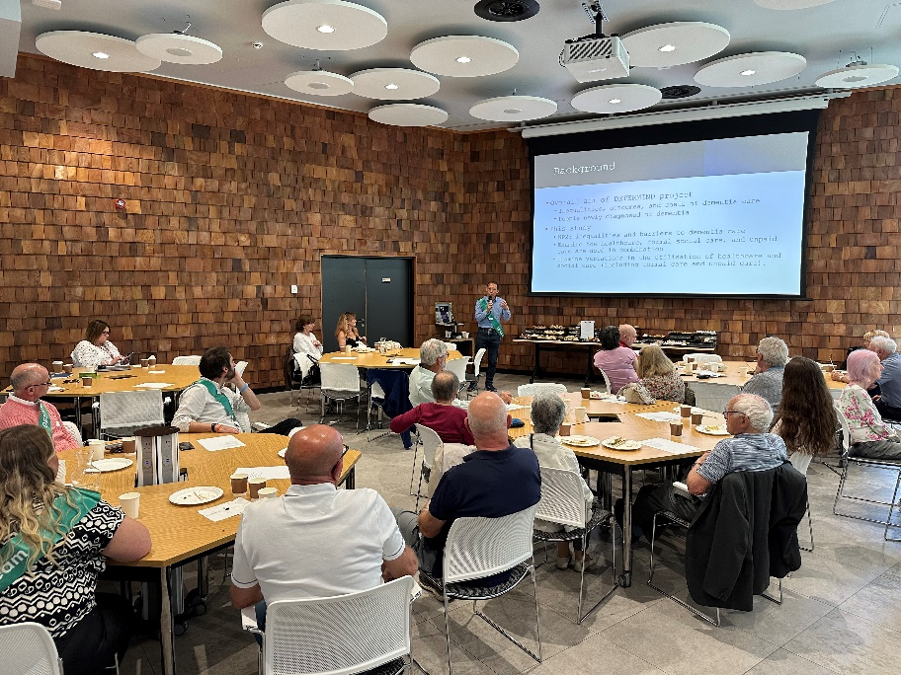
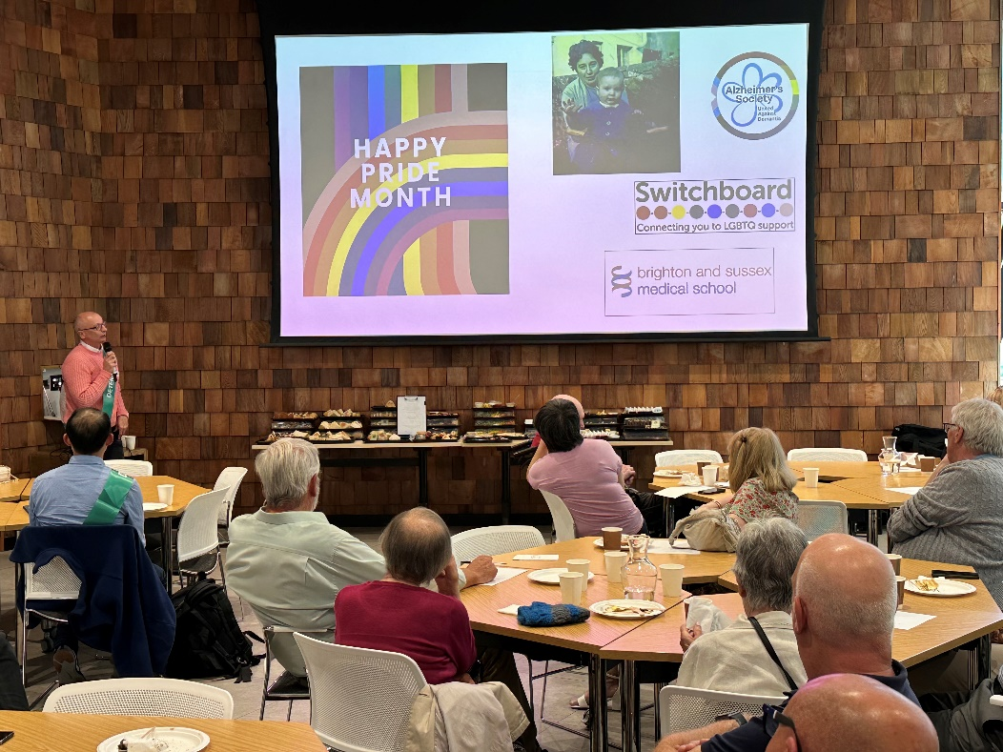
Bo Hu and the use of health and social care amongst persons living with dementia
John Hammon presents on the Candidacy Framework

Bo Hu: Use of health and social care among people living with dementia
Workstream 2 aims to identify the inequalities, outcomes and costs of dementia care, especially those who have been recently diagnosed. By engaging with those newly diagnosed with dementia, we aim to highlight some of the barriers to dementia care and examine how healthcare, social care, and unpaid care are combined in the care of a PLWD. By reviewing these variations, we can assess the impact of adequate care and make healthcare and social care more accessible to those diagnosed with dementia. Of the 915 participants in the DETERMIND sample, 32 lived in care homes, and we assessed the remaining 883 for analysis. Of the participants included in the final analysis, n=239 were recruited before COVID-19, and n=664 were recruited after. By understanding the use of health and social care services over the last three months, we can know whether the current service provision is meeting the needs of PLWD and what improvements are needed to make these services more accessible. Examining variations in utilisation, we can assess the outcomes for these individuals to improve the quality of the services we provide.
We identified a list of services and characteristics to assess the level of service use our participants engaged with. Personal Characteristics included
- Demographic Factors
  - Age
  - Gender
  - Ethnicity
  - Marital Status
- Health Status
  - Functional capability
  - Cognitive Functioning
- Socioeconomic Factors
  - Education
  - Occupation
  - Housing Tenure
- Location
  - Urbanicity
  - Study Sites (Gateshead, South London and Maudsley, Sussex)
  - Index of multiple deprivations.
Services included –
- Healthcare Services
  - Hospital Care
  - Memory Clinics
  - Urgent Care and Emergency services (A&E, paramedics and NHS 111)
  - Psychiatrists
  - GP Services
  - Nursing Services (District Nurses, Practice nurses or Admiral nurses)
- Social Care
  - Home Care (Home help services and personal assistants)
  - Unpaid Care
We identified four groups of users, which we have outlined below –
Extensive User Group | People in this group used a wide range of health and social care services to meet their care needs.
Selected use group A: | People in this group used a combination of memory clinic services and unpaid care to meet their care needs.
Selected use group B | People in this group used a combination of GP services and unpaid care to meet their care needs. People in the two selected use groups did use other services, but the usage of those services is pretty limited.
Minimal use group | Very few people in this group used health and social care services. In particular, none of them used psychiatrist or GP services.

People living with dementia have complex care needs. Our analyses suggest that people often use different types of care in specific combinations to meet these needs. This highlights the importance of coordinated and integrated care provision to meet the care needs of people with dementia fully.

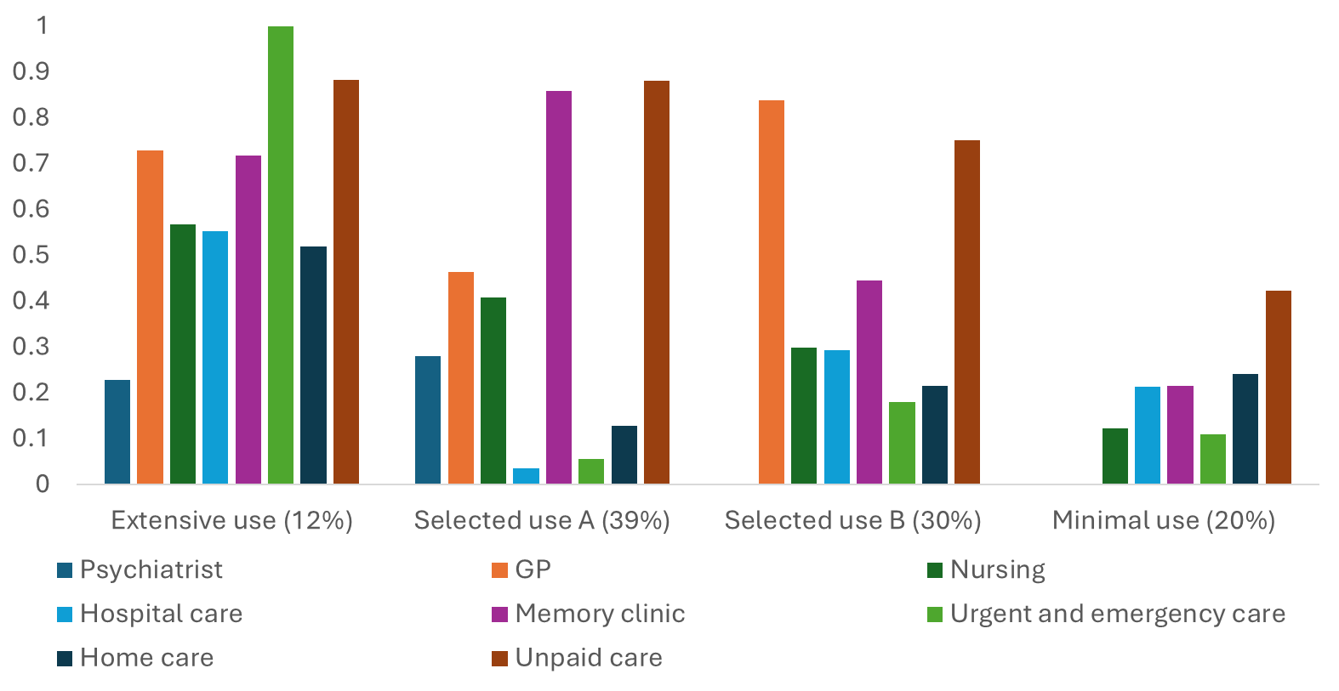
The selective usage of health and social care

The differences between the scales indicate the differences in service use. In the extensive service use group, participants used a wide range of services to support their needs significantly more than the other groups. In the minimal-use group, service usage was much less, which could be attributed to health inequalities for those who have been diagnosed with dementia. This can be further explored when we examine the service use of the different demographics.
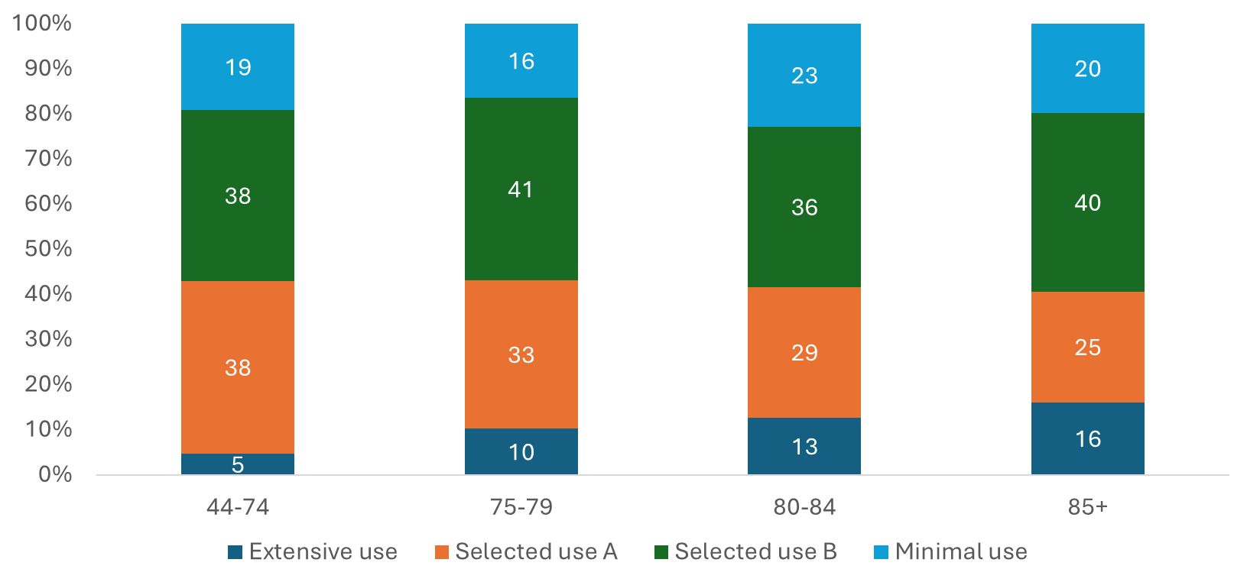
Service Use According to Age

Participants aged 44-74 showed less extensive service use than other age groups. Only 5% of adults within the group extensively used all services. 38% of participants in this age group mainly combined memory clinic services and unpaid care (i.e., selective use group A) and another 38% mainly selective use B group combined GP services and unpaid care (i.e., selective use B group) to meet their needs. Although people in select use groups A and B would use other services, they would be pretty limited. 19% of this group used a minimal amount of services and did not use psychiatrist or GP services at all. Of participants Aged 75 to 79, 10% had extensive use of services, 33% had selective use A (a combination of memory clinic and unpaid care), and 41% had selective use B (GP services and unpaid care) to meet their needs. 16% of participants had minimal use of services. Of Participants Aged 80 to 84, 13% had extensive usage, 29% had selective use A (a combination of memory clinic and unpaid care), and 41% had selective use B (GP services and unpaid care) to meet their needs and 23% had minimal usage of services. In the final age group of 85+, 16% had extensive usage of services, 29% had selective use A (a combination of memory clinic and unpaid care), and 40% had selective use B (GP services and unpaid care) to meet their needs, 20% had minimal usage of health and social care services.
It is important to understand health and social care use by age to identify whether people have increased needs as they age and whether age is an important factor for people living with dementia to access care. As older adults age, they engage with more extensive service usage when compared to younger groups and use a wide range of health and social care services to meet their needs. We can see decreases in selective usage A as people age, moving away from memory clinics and unpaid services to meet their needs. The importance of why these changes occur can help us understand our need for services as we age and suggests that our needs may change.
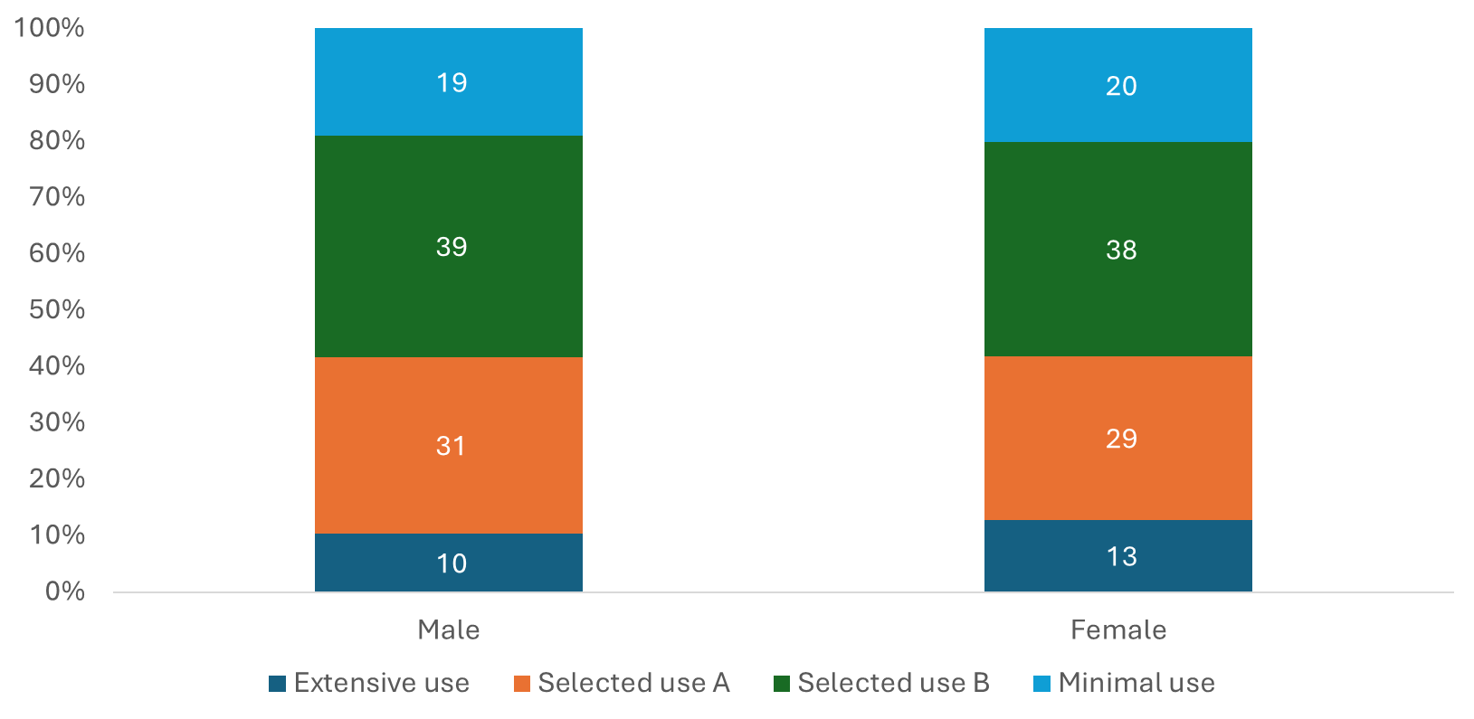
Service Use By Gender
When we look at service usage between the genders, we can see that for men, 10% of participants fell into the extensive use category, 31% had selective use A (a combination of memory clinic and unpaid care), and 39% had selective use B (GP services and unpaid care) to meet their needs, and 19% had minimal usage of services. For the female participants, 13% of participants fell into the extensive use category, 29% had selective use A (a combination of memory clinic and unpaid care), and 38% had selective use B (GP services and unpaid care) to meet their needs, and 20% had minimal usage of services.
By gender, participants had similar usage across the board, with only fractional changes in their service usage.
Service use according to Cognitive Impairment
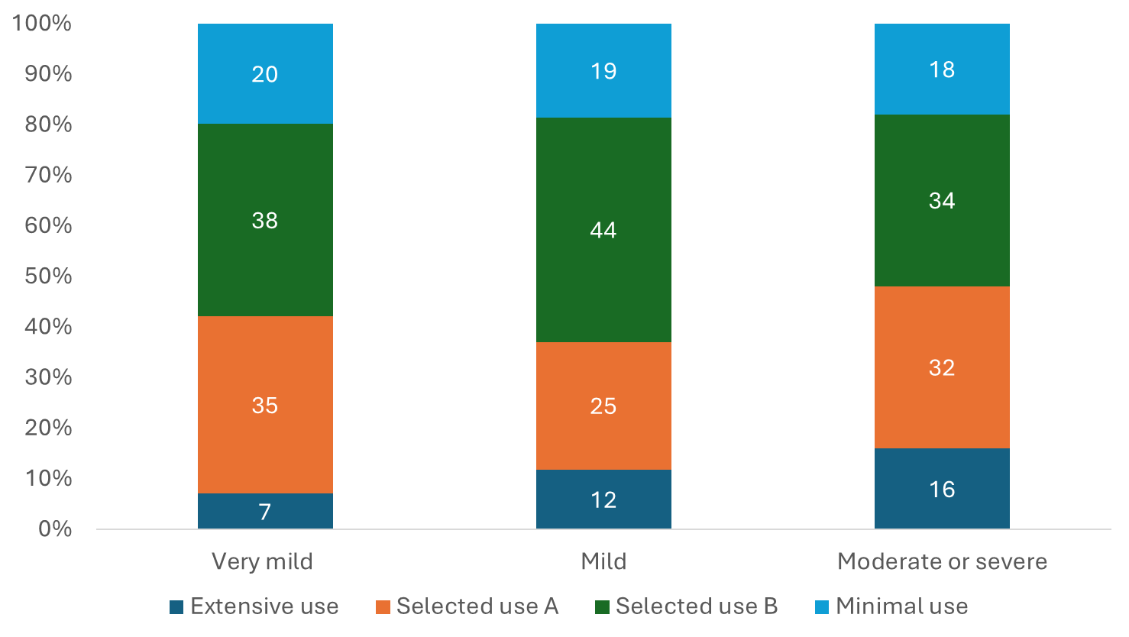
Changes in cognitive impairment can significantly affect service use. For those with very mild cognitive impairment, 7% of participants fell into the extensive use category, 35% had selective use A (a combination of memory clinic and unpaid care), 38% had selective use B (GP services and unpaid care) to meet their needs, and 20% had minimal usage of services. For the mild cognitive impairment group, 12% of participants fell into the extensive use category, 25% had selective use A (a combination of memory clinic and unpaid care), and 44% had selective use B (GP services and unpaid care) to meet their needs, and 19% had minimal usage of services. For those with Moderate or Severe cognitive impairment, 16% of participants fell into the extensive use category, 32% had selective use A (a combination of memory clinic and unpaid care), and 34% had selective use B (GP services and unpaid care) to meet their needs, and 18% had minimal usage of services.
As the condition worsens, there is a greater need for services between the groups. From the very mild to the moderate group, an increase of 9% of participants moved to the extensive use category, suggesting that there is a greater need for using a wider range of services to fully meet the care needs as the illness progresses. Within the mild group, 44% of participants required the most care from their GP and unpaid services to meet their care needs. However, interestingly, those who had minimal usage decreased slightly as the illness progressed (a decrease of 1% per group), posing whether those who have not been able to access services at earlier stages of their journey are less likely to engage as the illness progresses.
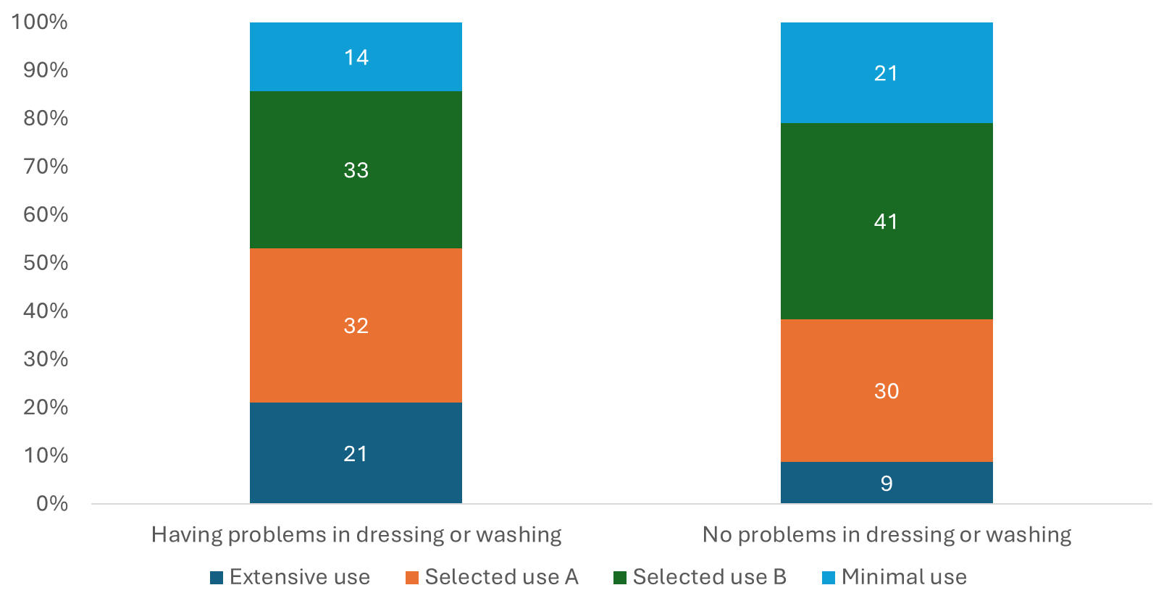
Service User group according to Self-Care Capability

For those who had problems washing and dressing, 21% of participants fell into the extensive use category, 32% had selective use A (a combination of memory clinic and unpaid care), 33% had selective use B (GP services and unpaid care) to meet their needs, and 14% had minimal usage of services. For those who had no problems washing or dressing, 9% of participants fell into the extensive use category, 30% had selective use A (a combination of memory clinic and unpaid care), 41% had selective use B (GP services and unpaid care) to meet their needs, and 21% had minimal usage of services.
We can see differences between the extensive use groups of those who had problems washing and dressing and those who did not. An increase of 12% indicates that physical ability may determine whether the participant has more extensive health and social care needs when they have problems washing and dressing. Changes in selective use A and B can be seen between the groups; for selective use A (use of memory clinic and unpaid services), a 7% increase can be seen in the group who have problems washing and dressing. In selective group B (using GP and unpaid services), a 9% increase in services is seen when the participant does not have any problems washing and dressing. Conversely, in the minimal-use group, we see a 7% decrease increase when the participants do not have problems washing and dressing. This is important because needing support washing and dressing changes the engagement in services, and we can see changes in how participants use the services available.
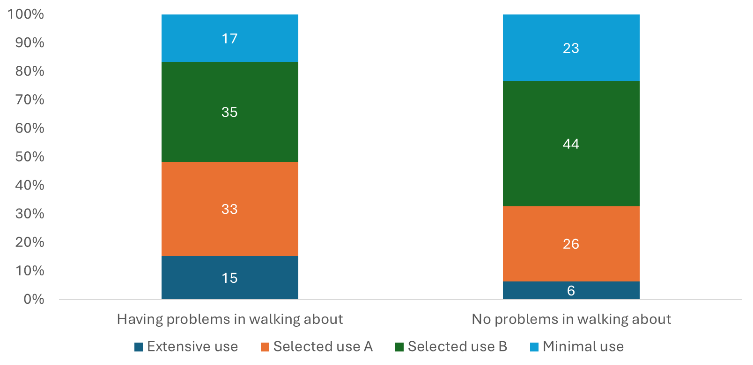
Selective Groups by Mobility

When we look at the groups broken down by mobility, participants who had problems walking: 15% fell into the extensive use category, 33% into selective use A (a combination of memory clinic and unpaid care), 35% into selective use B (GP services and unpaid care) to meet their needs, and 17% had minimal usage of services. For the group who had no problems walking about, 6% fell into the extensive use category, 26% into selective use A (a combination of memory clinic and unpaid care), 44% into selective use B (GP services and unpaid care) to meet their needs, and 23% had minimal usage of services.
Similar to the group who had problems washing and dressing, we saw an increase in extensive service usage (9%). For selective use A group, a change of 7% indicates that participants needed more support from their memory clinic and unpaid care services. Whereas a 9% change between groups can indicate that those who did not have problems walking about used more services provided by their GP and unpaid services. Interestingly, within the minimal-use group, a 6% change between those who did have problems with walking about and those who did not may show that more people with problems with their mobility are engaging with supportive services.
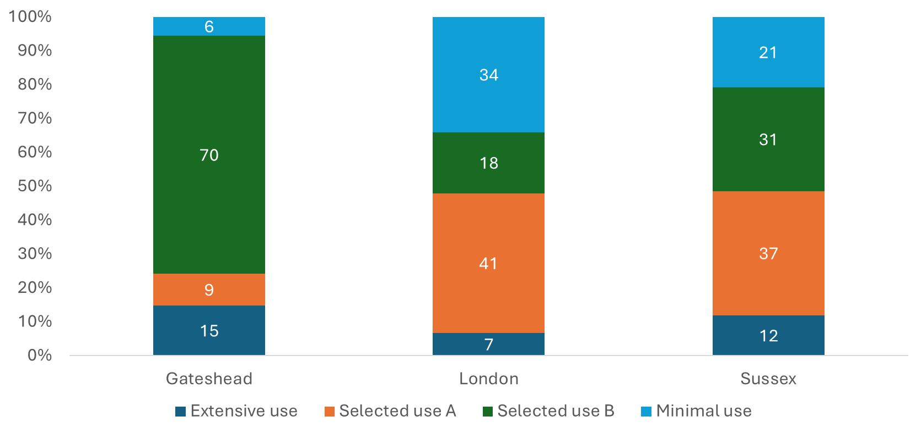
Service use According to Location

Overall, Gateshead had the best engagement of services, with 94% of the sample in this location falling into the extensive use or selected use groups. This contrasts service engagement in London (66%) and Sussex (79%). 15% of participants were extensive users, similar to Sussex at 12%, but nearly double for both sites compared to London at 7%. Select use A is much more common in London (41%) and Sussex (37%) than in Gateshead (9%). For service use B, the pattern is reversed: 70% of the sample in Gateshead falls into this category, which is compared to only 18% in London and 31% in Sussex. These numbers reflect a massive discrepancy between the services offered by these localities. The results of the analysis should be explored further to identify why those in Sussex and London report higher minimal usage scores and ascertain whether those differences are due to inequality in access to services.
Service use by Ethnicity
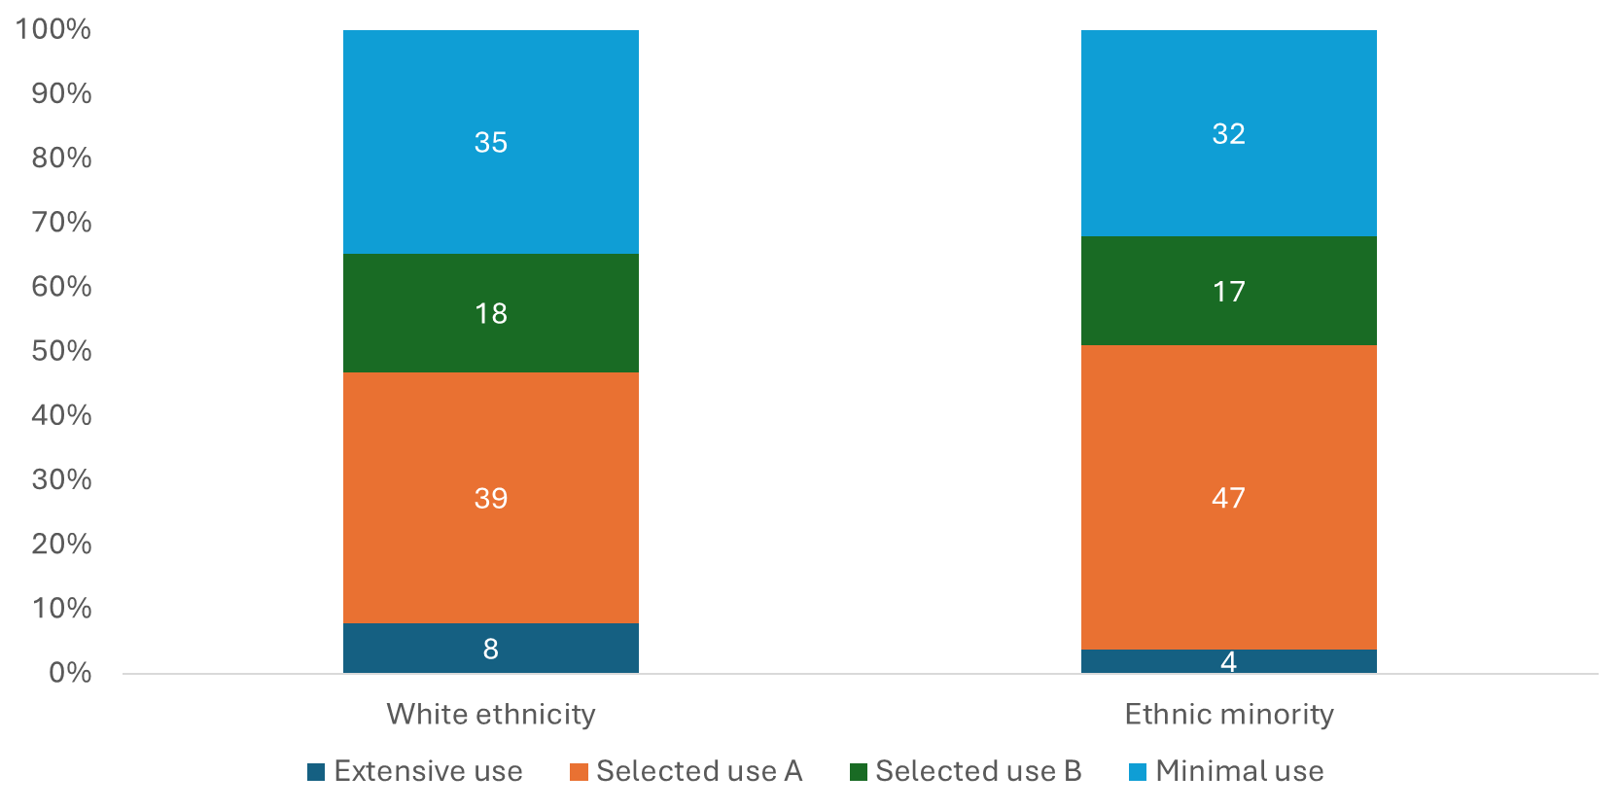
When comparing service use by Ethnicity, we can see that for those from a white background, 12% fell into the extensive use category, 29% into selective use A (a combination of memory clinic and unpaid care), 41% into selective use B (GP services and unpaid care) to meet their needs, and 18% had minimal usage of services. Of those who belonged to an ethnic minority, 7% fell into the extensive use category, 42% into selective use A (a combination of memory clinic and unpaid care), 16% into selective use B (GP services and unpaid care) to meet their needs, and 34% had minimal usage of services.

There was a notable difference between the groups, with minimal service engagement. 34% of participants from an ethnic minority reported minimal engagement with services, which is 18% less than those from a white ethnicity. For participants who reported extensive usage, those from a white ethnicity reported a 12% engagement higher than the 7% reported by ethnic minorities. Ethnic minorities reported higher selective use A (memory clinics and unpaid care) usage; 43% of participants reported use when compared to the 29% of participants who come from a white background. However, those from a white ethnic background reported higher selective use B (GP and unpaid care) usage, 41%, when compared to the 16% of ethnic minorities.
Service use from amongst survey users in London by Ethnicity (72%)
Within our sample, participants from London show the highest ethnicity comparison. Those who come from a white ethnic background reported 8% falling into the extensive use category, 39% into selective use A (a combination of memory clinic and unpaid care), 18% into selective use B (GP services and unpaid care) to meet their needs, and 35% had minimal usage of services. For those who come from an ethnic minority, 4% fell into the extensive use category, 47% into selective use A (a combination of memory clinic and unpaid care), 17% into selective use B (GP services and unpaid care) to meet their needs, and 32% had minimal usage of services.

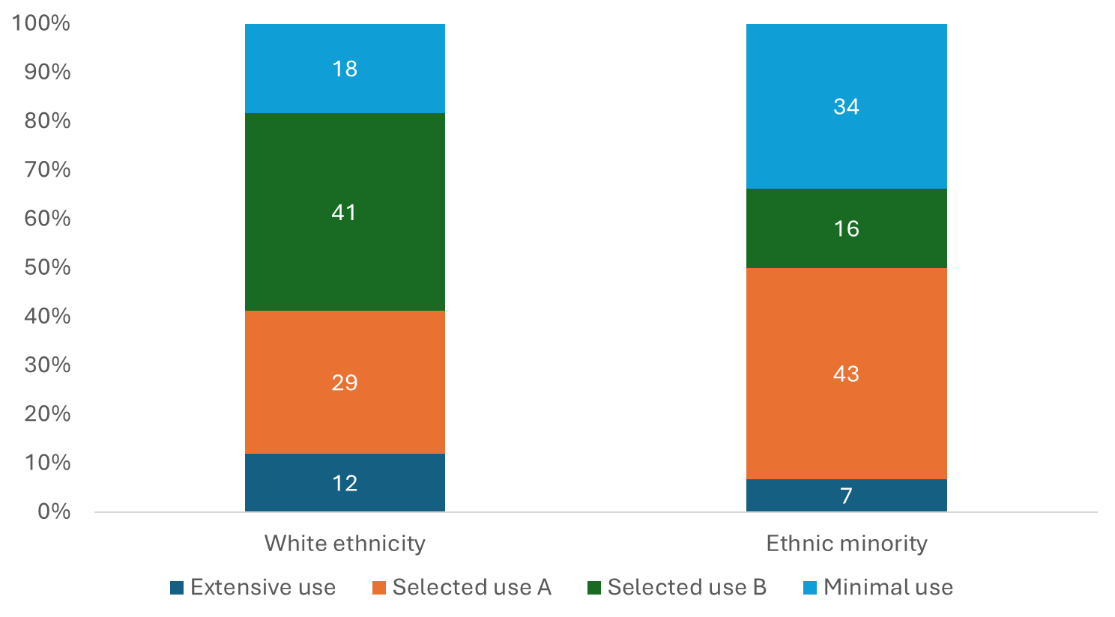
Between groups, 8% of those from a white background reported higher extensive usage than those from an ethnic minority, which was only 4%. Both groups have reported similar minimal usage scores for both white ethnicities and those from ethnic minorities (35% and 32%, respectively), which is still considerably high for both groups. Similar to the service used by ethnicity reports, those from an ethnic minority consistently report higher selective use A scores compared to those from a white background (47% and 39%, respectively). Similar scores can be seen in both groups of those with selective group B.

Key Findings and Summary
People living with dementia use different combinations of health and social care. However, this needs further exploration to understand how these services are provided and why people choose to use them. The implications for health and social care integration suggest that there needs to be higher levels of communication and coordination between unpaid carers and healthcare providers. The extensive use of dementia care suggested that people in higher age groups experience the progression of cognitive impairment and functional limitations, suggesting higher health and social care use. The integration of care becomes increasingly important with the progression of care needs. We can also see massive geographical variations in the use of healthcare services.
Our next steps include understanding the reasons for geographical variation in the care we provide, investigating the service use according to socioeconomic status and explore the costs of health and social care according to service across usage groups.

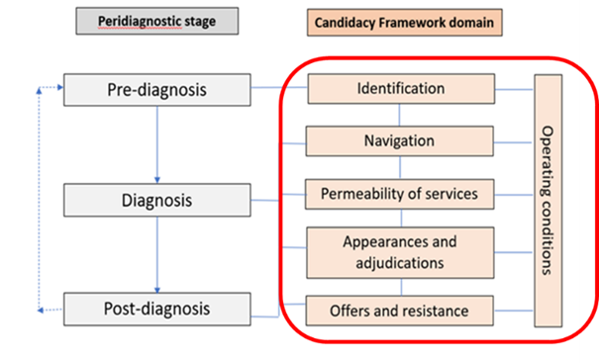
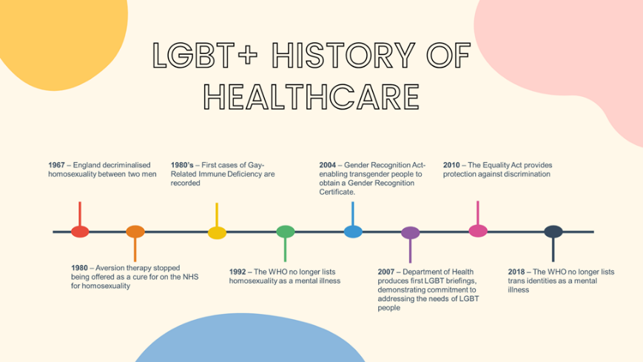
The Candidacy Framework is a new way to explore the experiences of lesbian, gay, and bisexual people living with dementia.
- Identification - Participants described pre-diagnosis symptoms and relied on trust in others. Some spoke of their symptoms as ‘part of the ageing process.’ For those PLWD who lived alone, difficulties in recognising symptoms resulted in delays in seeking help.
- Navigation – Participants spoke of using a lifetime of resilience to overcome barriers to accessing dementia services and support from their GPs. All participants referred to specialist MAS reported varying confusion about their experiences. Being proactive about care needs facilitates better health outcomes.
- Permeability of Services —Highly permeable services are more inclusive and accessible to negotiate. Less permeable services are more restrictive, present more barriers, and are more challenging to negotiate. Participants said they would like all healthcare professionals to receive an agreed-upon level of training about the needs of LGBT+ people.
- Appearances and Adjunctions —While all participants felt their LGB identities were integral to who they were, they were neither routinely asked at dementia services nor thought it was irrelevant to disclose this aspect of their identities.
- Offers and Resistance – The services offered (or not provided) and patients’ decisions to accept or decline such offers. Some participants reported no offers of ongoing formal support post-diagnosis and feelings of uncertainty about the future.

Key Findings and Reflections
- Participants do not freely disclose their identities to healthcare professionals, which may create barriers to healthcare provision.
- Gay male participants relied on a lifetime of resilience when navigating Healthcare Services.
- Our participants were concerned about their future care needs and how the formal care services would respect their LBGT+ Identities.
- Services must engage with LGBT people to hear their suggestions for improving services and making them more inclusive.
- By developing an ongoing relationship with these services, LGB+ people may feel more straightforward about disclosing their sexual and gender identities.
The History of LBGT+ individuals has been complicated. Understanding the challenges faced by the gay community can help us understand their unique service usage.

Highlights - John Hammond
Using the Candidacy Framework to explore the experiences of LGB+ PLWD

John Hammond: Using the Candidacy Framework to explore the experiences of LGB+ PLWD
With 1% of adults over the age of 65 identifying as LBGT+, it is essential to recognise the terminology associated with the community and why it is so important to assess the experiences of the LGBT+ community when accessing healthcare. Stonewall identifies the following definitions.
Lesbian | A woman who has a romantic and sexual orientation towards women.
Gay | A man who has a romantic and sexual orientation towards men.  It is also a general term for lesbian and gay sexuality.
Bisexual | A term used to describe a romantic and sexual orientation towards more than one gender.
Trans/Transgender | An umbrella term to describe people whose gender is not the same as, or does not sit comfortably with, the sex they were assigned at birth.

“It hasn’t always been rainbows and giggles.”

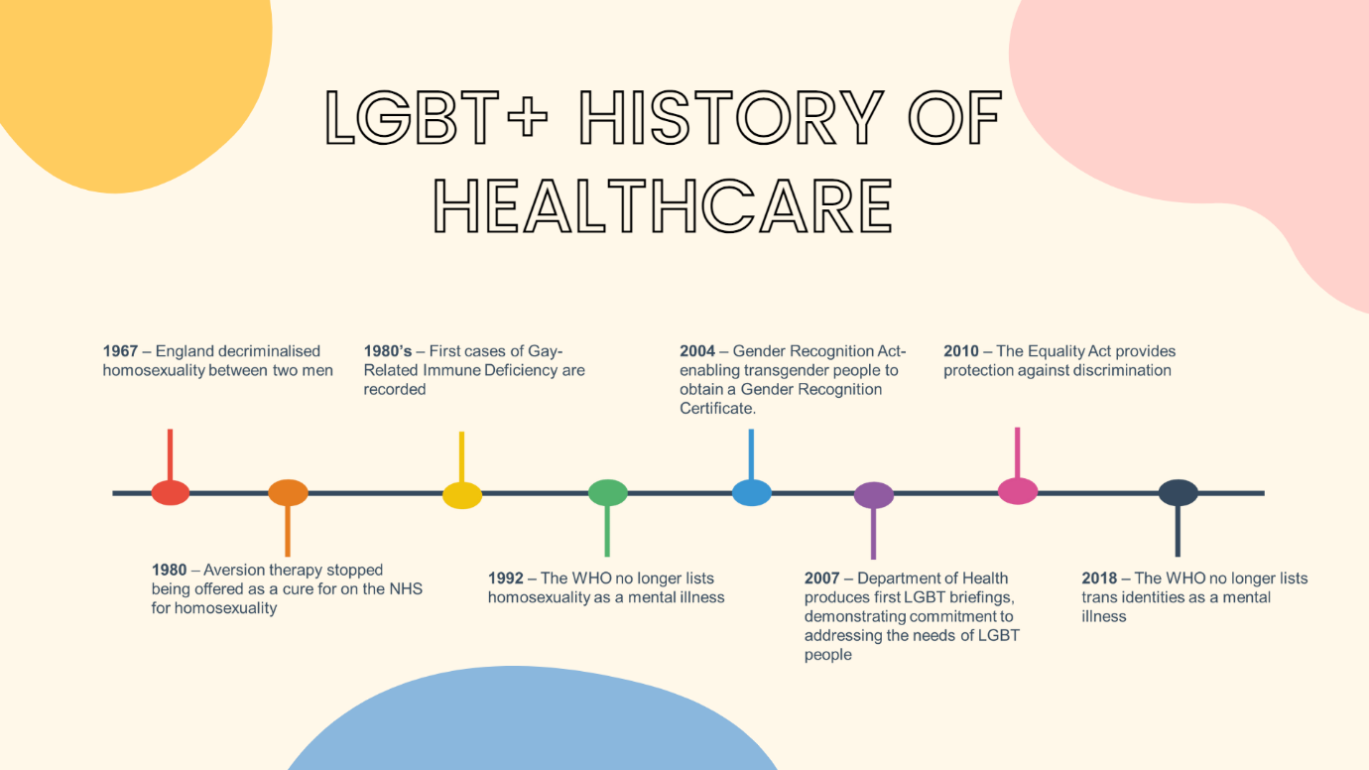

LGBT+ awareness has been a work in progress and has never been more critical for many of our older adults who may not have been freely able to live their sexual and gender identities without discrimination or marginalisation. The progress made over the past sixty-five years highlights the under-researched needs of the LGBT+ community. Looking into recent history illuminates why understanding LGBT+ rights is so important. In 1967, the first significant steps towards LBGT+ rights were made with the partial decriminalisation of homosexual acts between two men. Until then, homosexual acts between two men were a crime, which often carried a great weight of shame for gay men. To ‘cure their homosexuality’, people from LBGT+ communities were prescribed aversion therapy. This behavioural therapy pairs ‘unwanted behaviours’ (such as homosexuality) with physical or psychological discomfort or pain to associate homosexual thoughts with feelings of pain or discomfort. Aversion therapy was routinely prescribed to LBGT+ individuals until it was stopped in 1980. In the 1980s and 1990s the HIV/AIDS epidemic claimed many LBGT+ lives, with many activists battling the healthcare service for much-needed research into life-saving medications. In 1992, the World Health Organisation declassified homosexuality as a mental illness, seeking to improve the lives of the LBGT+ community.
Since the millennium, improvements in healthcare provision have been made. In 2004, the Gender Recognition Act was passed, allowing transgender people to obtain a gender certificate and live as their chosen gender. The Civil Partnership Act was also passed, giving same-sex couples the right to form civil unions with the same recognised rights as married couples. By 2007, the NHS committed to addressing the needs of the LGBT+ community and produced the LGBT+ Briefings. This survey captured the experiences of 108,000 people, detailing their experiences of discrimination whilst trying to access healthcare. The Equality Act (2010) was passed, setting out the personal characteristics protected under the law and the behaviours towards these individuals that were deemed unlawful. In 2018, the World Health Organisation declassified ‘Transgender’ no longer recognising it as a disorder. Despite considerable changes to legislation and societal attitudes since the 1960s, this progression may have a less significant impact on older adults who identify as LBGT+ and on their care needs.
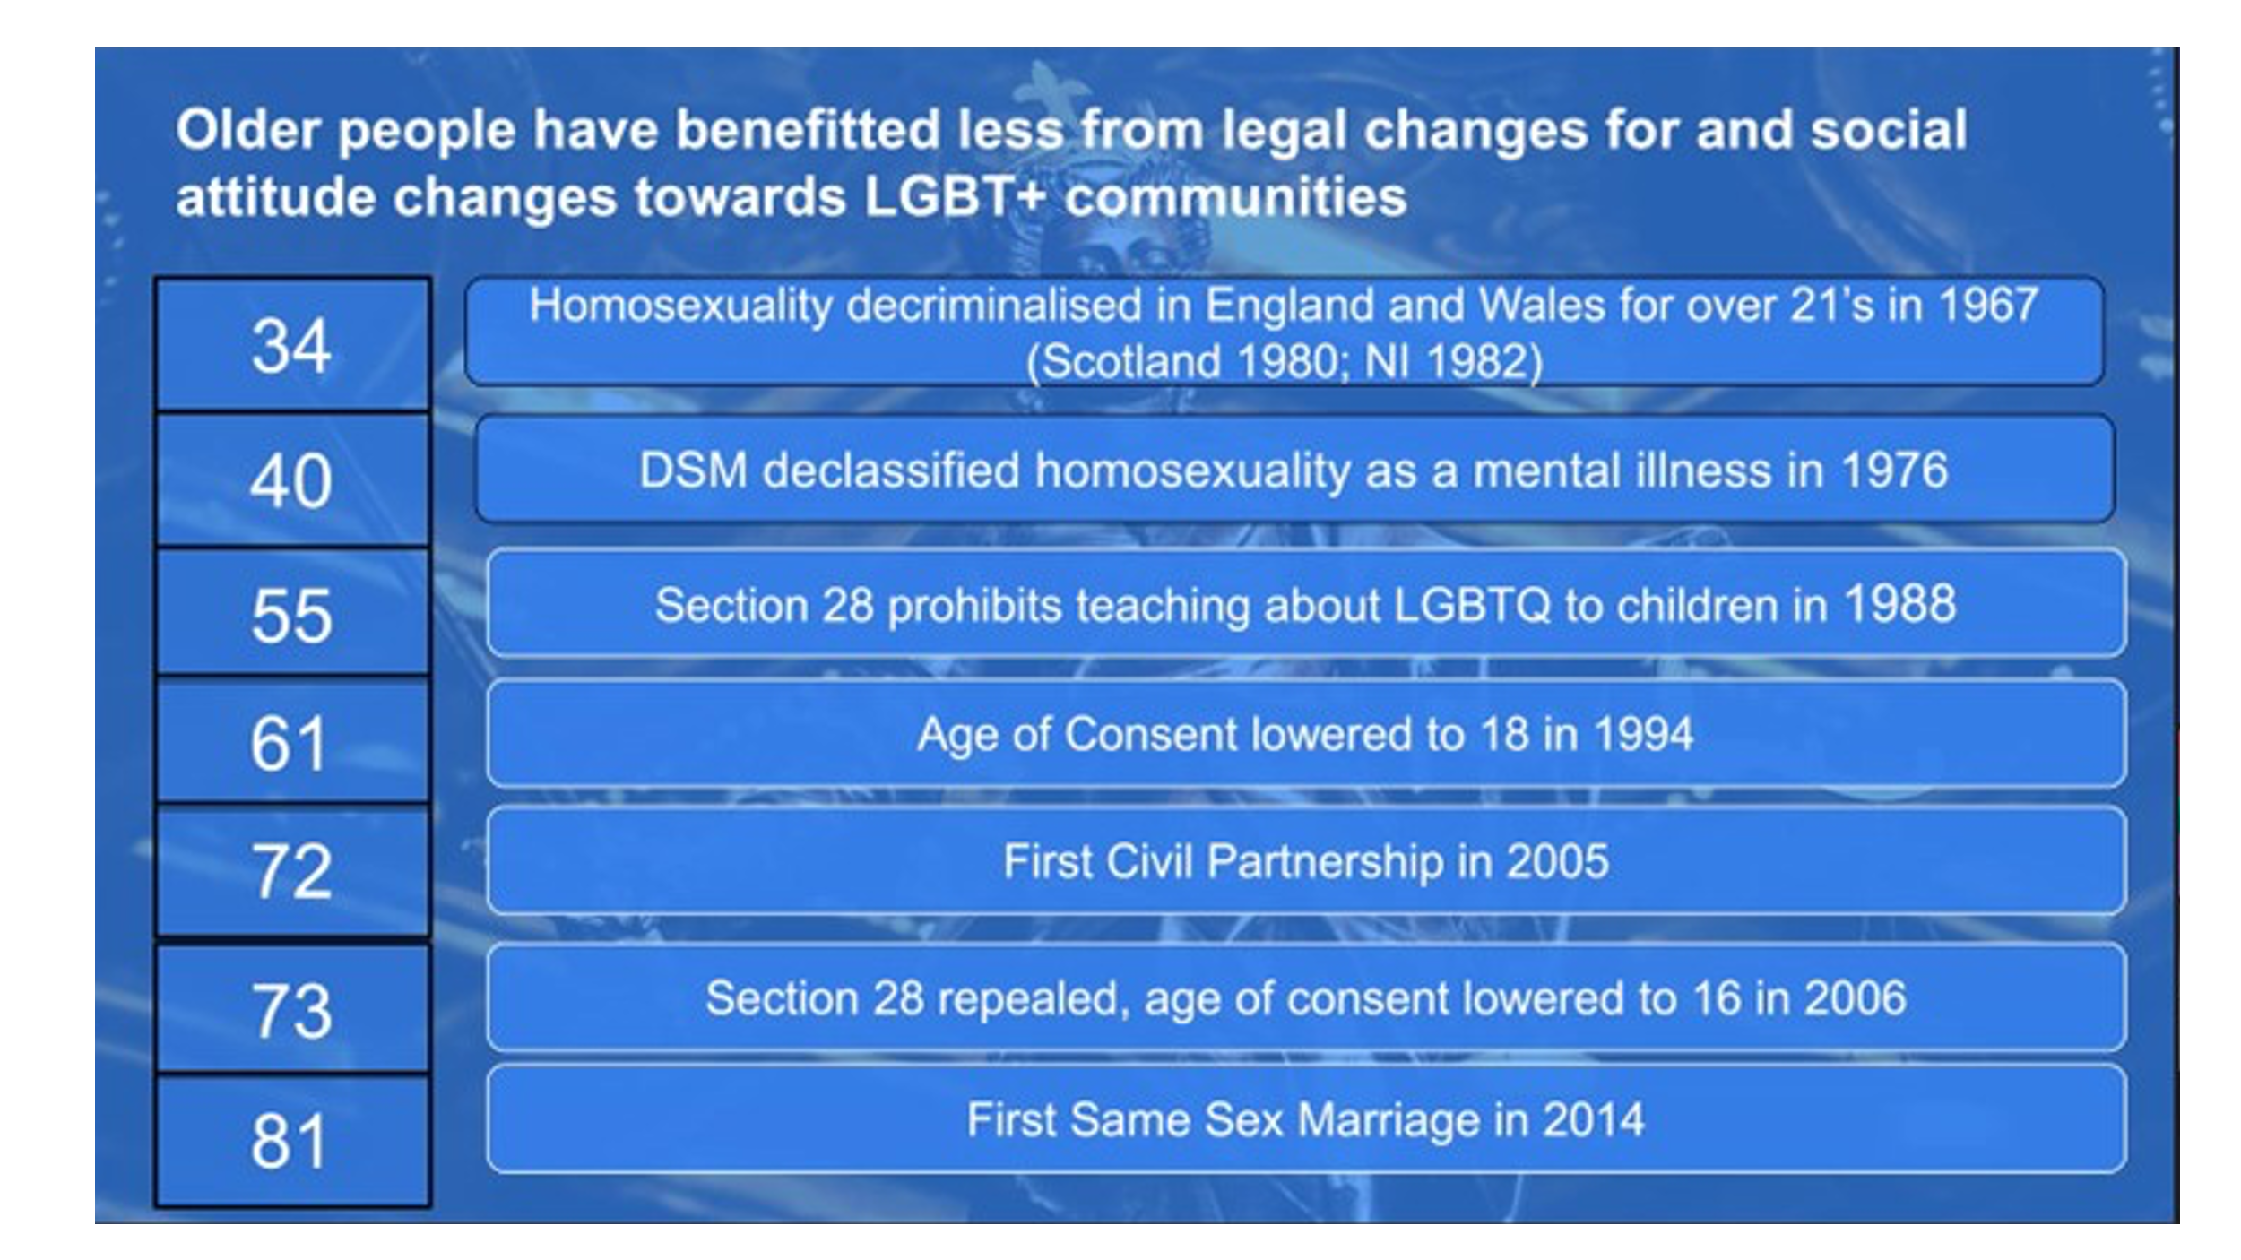
Older adults have benefitted less from the legal changes and attitude changes towards LGBT+ communities and may not have the same freedom to express or share their sexual and gender identities when compared to younger adults. Many older adults may still be hiding their sexual and gender identities and may struggle to be open to healthcare providers. Small changes, such as healthcare providers wearing their Rainbow Lanyards, can help older adults feel safe to disclose their sexuality and offer more individualistic service provision.

“It’s important that you’re here and we’re being recognised.”
Health and social care services play vital roles in supporting the independence and quality of life for PLWD and their Caregivers. However, barriers still exist, which may mean that some older LBGT adults may avoid seeking health and social care when needed and of most benefit. The stories and views of LGBT people living with dementia remain mostly missing, and we aim to understand these stories more to identify the specific needs of this minority. It remains essential to understand from first-hand accounts how dementia services may or may not reach LGBT people and to explore both the positives and the barriers they experience
I conducted semi-structured interviews with participants who identified as lesbian, gay, or bisexual from the broader DETERMIND study cohort. Five people were living with dementia, and three were partner caregivers. Their ages ranged from 53 to 82. They were located in either Brighton or London. After the content of the interviews had been written up, I looked at the transcripts to investigate key themes and concepts related to the Candidacy Framework.
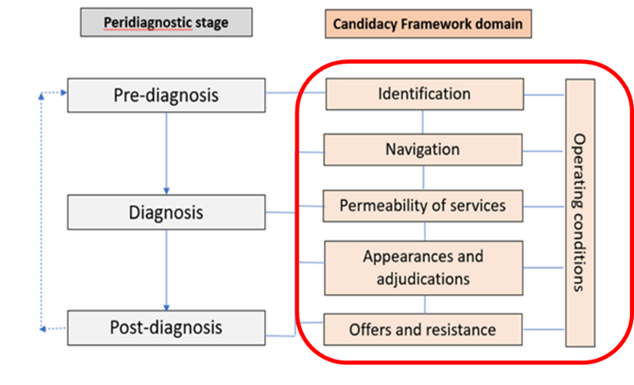
The Candidacy Framework is a new way to explore the experiences of lesbian, gay, and bisexual people living with dementia. The framework has six areas/dimensions that relate to the stages of a dementia journey – from pre-diagnosis to diagnosis and on to post-diagnosis
We conducted semi-structured interviews to explore each of these domains below.
The six main domains of the candidacy framework are -
- Identification - represents how older adults see themselves needing or using dementia services.
- Navigation – The awareness of the dementia services offered and the practicalities of using these services.
- Permeability of Services – The ease with which older adults can use dementia-based services.
- Appearances and Adjunctions – Understanding the professional preconceptions that may disadvantage LBGT+ older adults to access services.
- Offers and Resistance – Older adults may decline the offer of appointments if they cannot trust that their needs would be met within services.
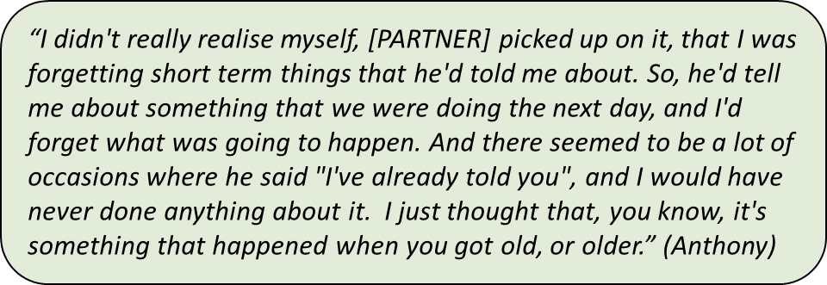
Identification: Participants described a range of pre-diagnosis symptoms and relied on trust in others to identify these. Some spoke of their symptoms as ‘part of the ageing process.’ Participants who worked in the healthcare profession were more aware of their symptoms. For those PLWD who lived alone, difficulties in recognising symptoms resulted in delays in seeking help.

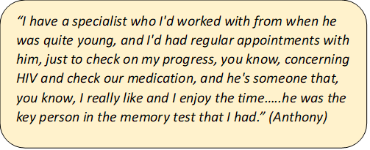
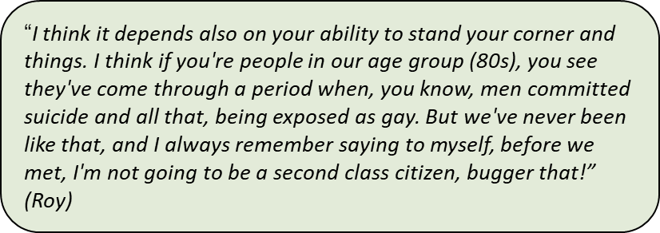
Navigation: Participants spoke of using a lifetime of resilience to overcome barriers to accessing dementia services and support from their GPs. All participants referred to specialist MAS reported varying confusion about their experiences. Being proactive about care needs facilitates better health outcomes. An established positive relationship with the diagnostic service significantly facilitated a timely and more positive experience of the diagnosis process.

‘Permeability’ of Services: Highly permeable services are more inclusive and accessible to negotiate. Less permeable services are more restrictive, present more barriers, and are more challenging to negotiate. Participants spoke of the importance of GPs providing flexible approaches and inclusive practices. Participants said they would like all healthcare professionals to receive an agreed level of training about the needs of LGBT+ people so that all services offer a consistent standard of inclusive support.
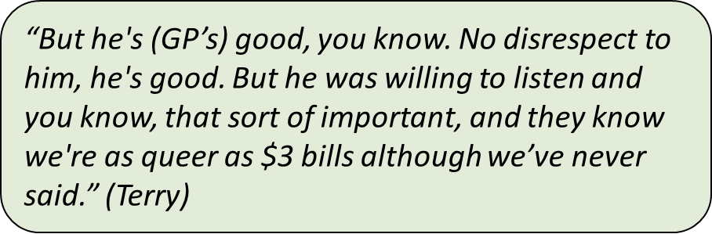
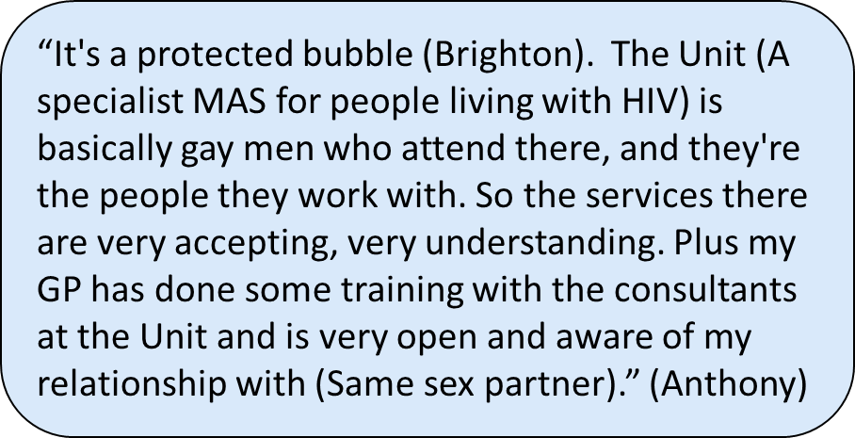

Appearances and Adjunctions: How patients and caregivers assert a claim for medical attention and how health professionals make judgments to provide a service. While all participants felt their LGB identities were integral to who they are, they were neither routinely asked at dementia services nor thought it was irrelevant to disclose this aspect of their identities.
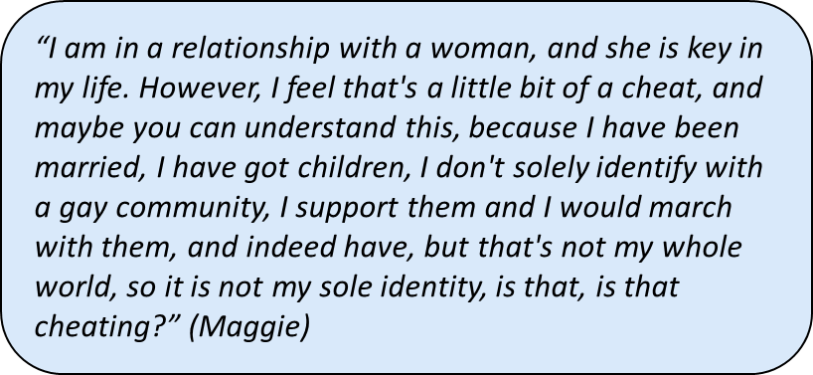
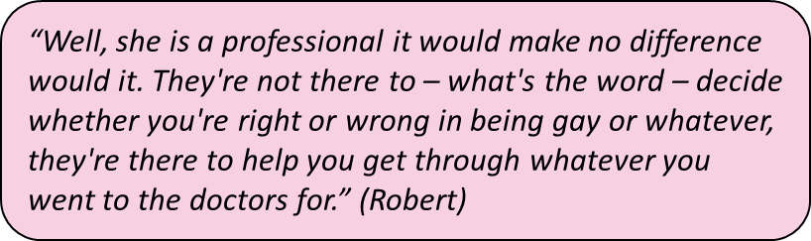
Participants believed generally that healthcare professionals would be inclusive and non-judgemental in their approaches and would apply fair processes for providing offers of care and support.

Offers and Resistance: The services offered (or not provided) and patients’ decisions to accept or decline such offers. Some participants reported no offers of ongoing formal support post-diagnosis and feelings of uncertainty about the future. All participants spoke of the importance of their informal support networks outside the provision of the dementia health services they interacted with. ‘Chosen family,’ ‘family of choice,’ or ‘rainbow family’ consisted of predominantly other LGBT+ people.

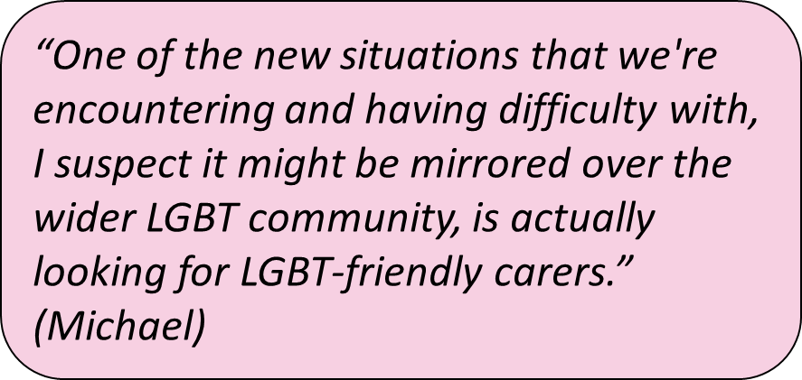
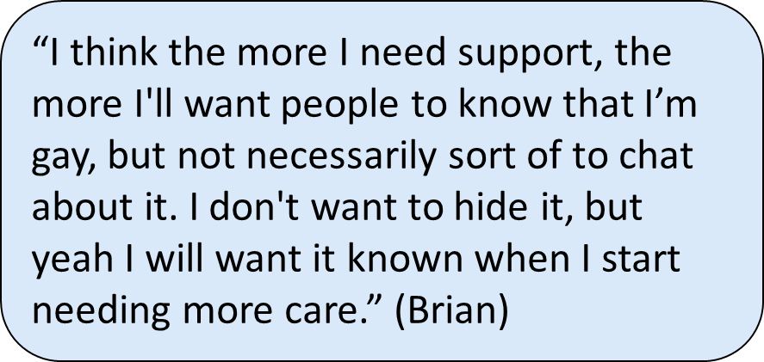

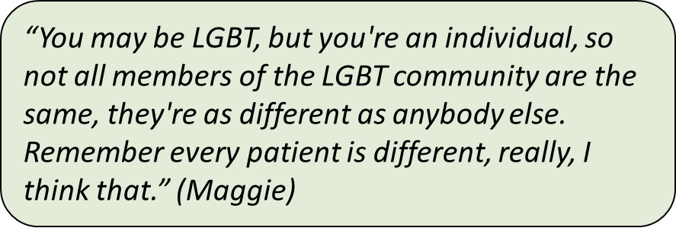
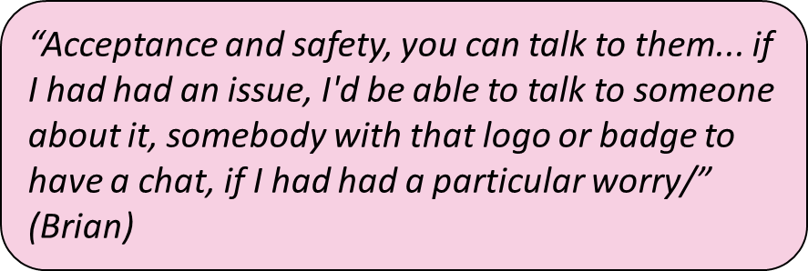
Offers and Resistance (Future care needs): All were concerned that their needs may increase over time, requiring both health and social care services and that more explicit disclosure of their LGB identities would be essential.

Operating Conditions: Organisational structures, resource availability, and policies affecting people’s healthcare experiences. Participants were keen to highlight the individuality of LGBT+ identities and for health services to interact with them based on this. The desire for signs, such as badges or logos on staff uniforms, was highlighted as symbols of acceptance and allyship with LGBT+ people.
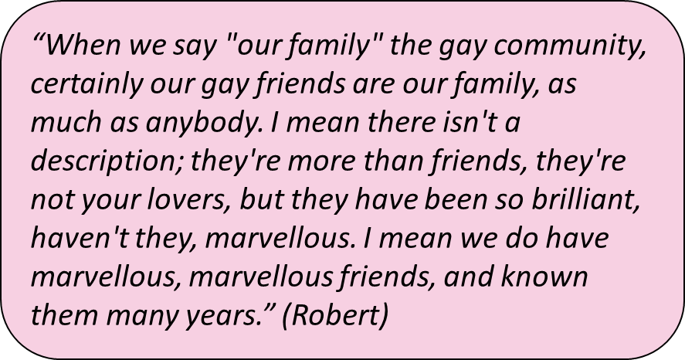

Key Findings and Reflections
We found that our Participants did not freely disclose their LBGT+ identities to dementia service professionals despite feeling that this was an essential part of who they are. They felt unsafe to disclose until a relationship was developed routinely, but this could be complicated by changing professionals. Gay male participants relied on their resilience in overcoming previous experiences of overcoming a lifetime of discrimination to navigate complicated dementia care systems; their ability to overcome adversity was an asset to help gain needed support. LGB+ individuals relied on Informal networks of ‘chosen families’ who provided essential care and support networks. An absence of specific support services for LBG+ PLWD was reported. Our participants were concerned about their future care needs and how the formal care services would respect their LBGT+ Identities.
Services must engage with LGBT people to hear their suggestions for improving services and making them more inclusive. Understanding the specific needs of the LGB+ community can help us understand how to make services universally accessible to minority groups. The collection of sexual and gender identity information sensitively and with context can help us understand how many LBG+ people use our services and engage with them to assess whether their care needs are being met. Although good practice guides exist, support services for LGBT people living with dementia may be community-based, online, or outside of statutory services, and each context should be explored to ensure accessibility. By developing an ongoing relationship with these services, LGB+ people may feel more straightforward about disclosing their sexual and gender identities, which is a dynamic and complex process that individuals, organisational practices, and context and timing may influence. Campaigns are needed to raise awareness of brain health in minoritised communities.

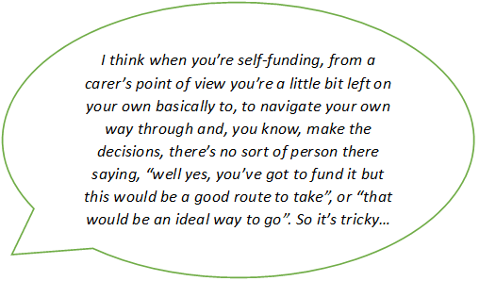

–

The Absence of Formal Support
We conducted in-depth interviews with people who pay for social care, those who get their care paid for by the local authority (or pay contributions) and those who don’t get any social care but may have to pay for it in the future
Many self-funders have never approached their local authority for help, and those who had have said that they received little support once it became clear they would be self-funding.

In England, health care services are free at the point of use, but social care is means-tested with tight eligibility criteria. Most social care users pay something towards the cost of their care, and those who pay the total costs are referred to as ‘self-funders’ But what do we mean by social care? It can be defined as any non-medical help to live life how you want, like care or equipment to stay at home or support to get out and about. Social care also covers residential care (care homes), social work and some services offered by charities.
We conducted semi-structured interviews to learn about the experiences of those navigating the social care system.
73% of our participants (n=103) were paying for this themselves, compared to the 21% who were able to gain funding from their local authorities (n=30) or the 6% who did not know about their funding status

Kate Gridley - The Experiences of People Who Pay for Care

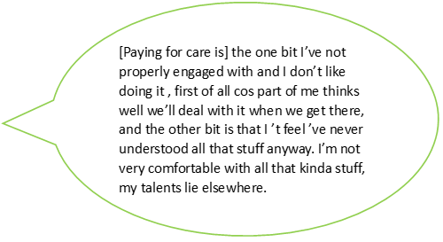
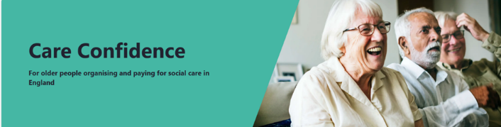


Care Planning
Participants reported that even if they knew where to start, uncertainty would prevent them from knowing what care they may need or when they need the support.
While people recognise they may need to pay for their care in the future, this does not necessarily mean they have made a plan.

Navigation Capital
Drawing on family, especially those with professional experience working in adult social care, was an advantage to getting the needed support.
In absence of formal support from the local council, self-funders rely on their own experiences, skills, and confidence, as well as the experience, skills, and confidence of the social contacts they can call upon to support them in navigating the social care system. We call this ‘Navigation Capital’.

‘Care Confidence’ is a new online planning tool that aims to help self-funders and their care partners understand their choices for social care and think about how best to fund their future and ongoing care. It is free for members of the public and organisations to use.

Social Care Talk – Thinking about future care needs and costs. Social Care Talk has many short videos from real people discussing their experiences on navigating the care system.

Useful Resources

I think if you, if you’re supported by family that are quite clued up, you’re in a much stronger position. I mean if you, I mean my, my husband used to be a social worker so, you know, we are aware of the support that’s out there…

Kate Gridley – The Experiences of People Who Pay for Care: Social Snake and Ladders
In England, health care services are free at the point of use, but social care is means-tested with tight eligibility criteria. Most social care users pay something towards the cost of their care, and those who pay the total costs are referred to as ‘self-funders’. But what do we mean by social care? It can be defined as any non-medical help to live life how you want, like care or equipment to stay at home or support to get out and about. Social care also covers residential care (care homes), social work and some services offered by charities.
Within the DETERMIND project, most people using homecare at baseline were self-funders. 73% of our participants (n=103) funded their care, compared to the 21% who were able to gain funding from their local authorities (n=30) or the 6% who did not know about their funding status (n=8).
 | Number | %
Self-Funded | 103 | 73%
Local Authority Funded or Combined Funding | 30 | 21%
Other/Didn’t Know | 8 | 6%
Total Responses | 141 | 100%
Table 1- Self Funding vs LA Funding based on PLWD and carers at first DETERMIND interview

Self-funding can be challenging, and when deciding care, choices are often made during times of crisis and self-funders and their families want help from their professionals to make choices. However, having money does not guarantee greater social control. For people living with dementia, we are interested in learning about the challenges of navigating the social care system, whether things change over time for people who provide funding for their care and whether the experiences differ between self-funders and people who are funded by councils.

The Absence of Formal Support
We conducted in-depth interviews with people who pay for social care, those who get their care paid for by the local authority (or pay contributions) and those who don’t get any social care but may have to pay for it in the future. A total of 67 interviews were completed. We found that many self-funders have never approached their local authority for help, and those who had have said that they received little support once it became clear they would be self-funding.
Carer of mum with dementia (self-funder; interviewed 3 times)
I think when you’re self-funding, from a carer’s point of view you’re a little bit left on your own basically to, to navigate your own way through and, you know, make the decisions, there’s no sort of person there saying, “well yes, you’ve got to fund it but this would be a good route to take”, or “that would be an ideal way to go”. So it’s tricky…

DETERMIND self-funders were less likely to report receiving formal support to navigate services than those with local authority-fundingOnly 25% (26/103) of those who self-funded homecare reported having social care assessments, which people have a right to regardless of their financial situation. 12.5% had a named care co-ordinator, compared to 33% of those funded by the local authority, and 8.8% had a named social worker, compared to 39% who received funding from the local authority. These numbers are concerning as the Care Act (2014) has given local authorities clear guidance to help self-funders secure social care.

Navigation Capital
So, what does help self-funders navigate the social care system? Without formal support, self-funders rely on their own experiences, skills, and confidence, as well as the experience, skills, and confidence of the social contacts they can call upon to support them in navigating the social care system. We call this ‘navigation capital’. The DETERMIND interviews have identified the importance of navigation capital, and we have included some quotes from our participants to help illustrate this point.
I think if you, if you’re supported by family that are quite clued up, you’re in a much stronger position. I mean if you, I mean my, my husband used to be a social worker so, you know, we are aware of the support that’s out there…

Carer of mum with dementia (self-funder; interviewed twice)
Interview 1: Carer of Mum with Dementia
Q: Is there anyone that you can talk to about [residential care] and get some advice?
A: I don’t know where to go really.
Q: Right, OK. So there’s not, you’re not in touch with anyone really who, who can give you advice on that?
A: No.
Q: So the in, the internet is your main source of information at the moment?
A: Yes
The first quote represents the value of navigation capital. Drawing on family, especially those with professional experience working in adult social care, was an advantage to getting the needed support. The second quote identifies that their loved ones can struggle to find the care they need without knowledge of the social care system. The result of the second quote is that when they were interviewed for the third time two years later, they reported that their mum had moved into a poor quality but expensive care home, and she would not recommend the home to anyone else. The participant would not move her mum now though, as she is settled.
Navigation capital could be a particular issue for self-funders with dementia. Evidence suggests that social networks can reduce as dementia progresses, and cognitive impairment may make it harder to draw on prior experiences to make informed choices. People living with dementia may also have complicated arrangements with the other people who help to provide their care and have an input in the decision-making process. Once decisions have been made, it can be hard to go back and change things, especially as the people with dementia becomes more familiar and stable within the new environment.
Social care self-funders are less likely to get formal support to navigate the social care system, which leaves them to fall back on their own navigation capital to make sense of this complicated system. People who live with dementia may be less likely to be able to draw on navigation capital due to their cognitive impairment and shrinking social networks, putting more pressure on their family and carers to source suitable social care. This research identified a need for more support from formal services to help people with minimal navigation capital make sense of the social care system and access the care they need.

Care Planning
To better understand the care planning process, we asked our participants whether they were thinking about how they might pay for care in the future and if anything had helped with this planning. We also asked whether there had been anything which had made things more difficult to plan for care. We discovered that, whilst people recognise they may need to pay for their care into the future, this does not necessarily mean they have made a plan. Participants reported that even if they knew where to start, uncertainty would prevent them from knowing what care they may need or even when they need the support. They recognised that things would change over time and wanted to enjoy things when they were ok. So why plan when things always change?

I’ve just realised that there ’s no point in really sort of planning, because it’s just like – it did change all the time … it was just doing my head in. So I just think, I’ll just take it as it is, and unless there’s – we’ll deal with whatever happens when it happens, kind of thing. Because the pre-planning is not worth it. always change. …

Daughter of participant with dementia
Participants have also reported that they have found the system hard to understand and put off care planning because of a lack of precise guidance. Not knowing where to start could be off-putting for people living with dementia and their careers.
Person with Dementia
[Paying for care is] the one bit I’ve not properly engaged with and I don’t like doing it , first of all cos part of me thinks well we’ll deal with it when we get there, and the other bit is that I ’t feel ’ve never understood all that stuff anyway. I’m not very comfortable with all that kinda stuff, my talents lie elsewhere.
Others found it helpful to get advice before making a plan.
Daughter of a person with dementia.
With the financial consultant it was more about how we could make her money last as long as possible, you know, cos we didn’t know at that point whether she would be able to manage independently …she wants to be at home, and she wants to do everything she possibly can to make sure she can stay there.

Useful Resources
Below are some resources to help you plan for the care you need and how to access that support.



Social Care Talk – Thinking about future care needs and costs.
Social Care Talk has many short videos from real people discussing their experiences. The link above can help you understand from others' experiences of planning to meet the costs of care, planning before care reaches the point of crisis and thinking about moving or adapting your home to meet your needs.
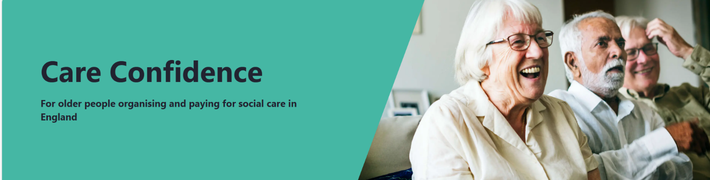
‘Care Confidence’ is a new online planning tool that aims to help self-funders and their care partners understand their choices for social care and think about how best to fund their future and ongoing care. The tool was developed by researchers at the Universities of York and Birmingham with self-funders, carers, and other stakeholders interested in improving self-funders outcomes. It is free for members of the public and organisations to use.
Care Confidence is evidence-based and brings together a wealth of information about navigating social care systems and self-funding care. Using short videos and case studies, it provides accessible information and a facility to enable people using Care Confidence to create their action plans.


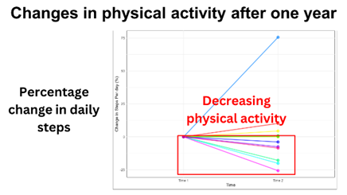
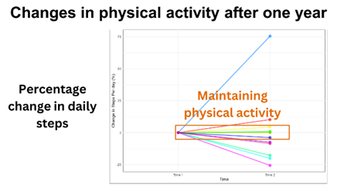
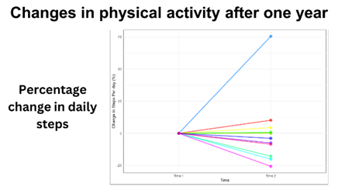
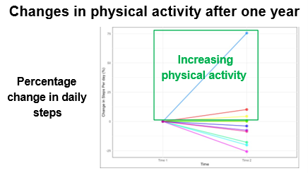

Ríona McArdle

Staying physically active with dementia: Early insights from ActivDem

The images to the left show the trajectories of change for participants' physical activity at timepoint 1 (baseline) and timepoint 2 (1-year follow-up).
Within the graph, we can see three separate groups:
Group 1: people who are increasing their physical activity (steps per day) within the year (from timepoint 1 to timepoint 2) - understandably, we view this increase as very beneficial and would use this group to try to help understand what caused the increase.
Group 2: participants who maintained their physical activity (steps per day) within the year - it is essential to understand that maintenance is still an awe-inspiring result for this cohort
Group 3: Participants whose physical activity (steps per day) is declining within the year (from timepoint 1 to timepoint 2)—We want to understand what causes this loss of PA and see if there is any link
We want to understand better the actual driving forces behind these changes.
For people with dementia, staying physically active can help them stay independent for longer, maintain their memory and thinking abilities, and slow the progression of changes within their brains.
We asked why staying physically active was essential for persons living with dementia, some reasons included -
Improved Mental & physical health:
“It affects mental health as well as dementia… so important for muscle and bone health, for stopping further falls”
Improved Sense of purpose:
“It’s what kept my dad going”
Improved Independence:
“When he started to decline, he gave up his hobbies. Without them... he’d be really irritated and to the point of aggression. His independence was being taken away”

What does Physical Activity look like in Dementia?
The range of activity monitored within PLWD can vary wildly. Individuals with mild dementia living at home have an average of 9,910 steps per day, and their daily steps range from 1,141 to 27,242. People who have moderate to severe dementia living in a care home had an average of 5,251 steps per day, and their daily steps ranged from 289 to 27,243.
Both of these sets of daily steps range wildly, and the level of cognition does not impact the volume of physical activity.
Persons Living with dementia have specific barriers which prevent them from being physically active. Some older Adults need some support with their anxiety, which may prevent them from being confident enough to be physically active. Some older adults may have a fear of falling and may not have the right level of support in place with their carers.

Ríona McArdle - Staying physically active with dementia: Early insights from the ActivDem x DETERMIND studies
For people with dementia, staying physically active can help them stay independent for longer, maintain their memory and thinking abilities, and slow the progression of changes within their brains. Physical activity is not only the time they spend at the gym or engaging in intensive exercise like weightlifting and running; their levels of activity when engaging with daily tasks, such as going for a walk, housework, shopping, laundry, or visiting family and friends, all count towards their daily activity levels. Staying physically active is essential for persons living with dementia for various reasons.
Mental & physical health:
“It affects mental health as well as dementia… so important for muscle and bone health, for stopping further falls”
Sense of purpose:
“It’s what kept my dad going”
Independence:
“When he started to decline, he gave up his hobbies. Without them... he’d be really irritated and to the point of aggression. His independence was being taken away”

The NHS guidelines often focus on the illness rather than the person living with dementia, and clinical staff often hold negative perceptions about the ability of people with dementia to engage in physical activity. Physical activity is not mentioned within the NHS guidelines for post-diagnostic care of people with dementia. However, many people living with dementia are still physically active and having dementia does not significantly explain why some people are physically active while others are not.

What does Physical Activity look like in Dementia?
The range of activity monitored within PLWD can vary wildly. Based on one study in Newcastle, individuals with mild dementia living at home have an average of 9,910 steps per day, and their daily steps range from 1,141 to 27,242. Based on another study set in New Zealand care homes, people who have moderate to severe dementia living in a care home had an average of 5,251 steps per day, and their daily steps ranged from 289 to 27,243. Both of these sets of daily steps range wildly, and the level of cognition does not impact the volume of physical activity. This may mean that something other than their dementia is driving their physical activity. As an example, we can look at two cases of people living with Lewy body disease with similar levels of movement problems and cognitive issues. . Participant A could stay active for 6 hours daily, whereas Participant B could only achieve 20 minutes of activity. Even those with the same diagnosis have variant ranges of activity. Anecdotally, we know that Participant A is part of a hiking group, and their family was very determined to keep them engaging with that group, while Participant B’s family were very worried about them and keen to keep them sitting down while the family looked after them.

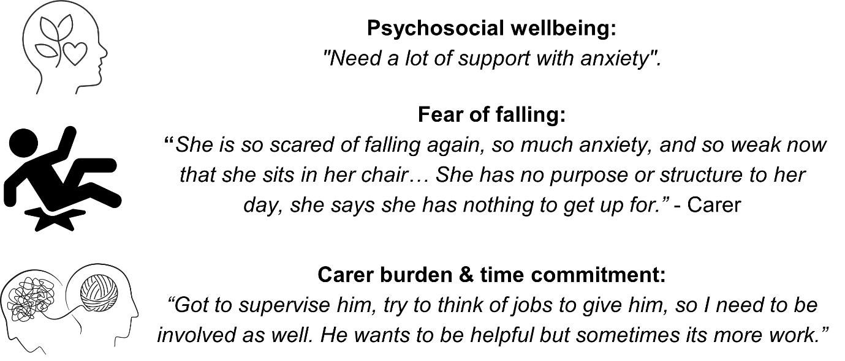
Persons Living with dementia have specific barriers which prevent them from being physically active. Some older Adults need some support with their anxiety, which may prevent them from being confident enough to be physically active. Some older adults may have a fear of falling and may not have the right level of support in place with their carers. We can help our older adults become more active by increasing their social support, resilience, and well-being and including other non-exercise-related activities. When carers have higher levels of physical activity, this has a knock-on effect on the PLWD and can support both to live more active and healthier lives.

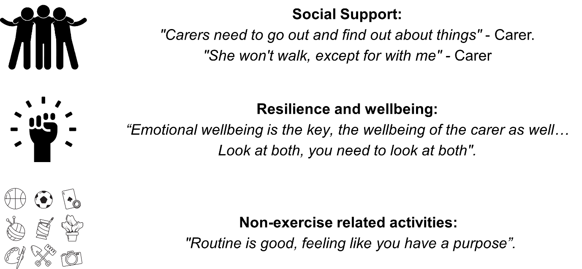

Early Insights from ActivDem
We have assessed 116 participants with dementia and followed up 16 one year later. From the first 101 participants, the average age of our participants was 80 years, and 61 were men and 40 were women. 62% had a diagnosis of Alzheimer’s disease, and the average time since diagnosis was 22 months—the stages of dementia range from Mild to Severe. On average, our participants completed 9,321 steps daily, ranging from 1,281 to 21,510, and spent 2 hours per day physically active, ranging from 20 minutes to 5 hours. Preliminary results suggest that being more physically active is associated with being younger, being male, having more social engagement, less carer requirements and a more emotional coping style. A person’s level of cognitive impairment was not associated with the amount of physical activity they do. This suggests that physical activity may be influenced by aspects beyond the condition of dementia itself, but by the way that they cope with the diagnosis and how much social support they receive.
The project also looked at changes in physical activity over one year in 16 participants. By understanding the difference between time points, we can assess the impact of a dementia diagnosis on activity levels and whether improving these levels can help improve the outcomes of people after a dementia diagnosis.

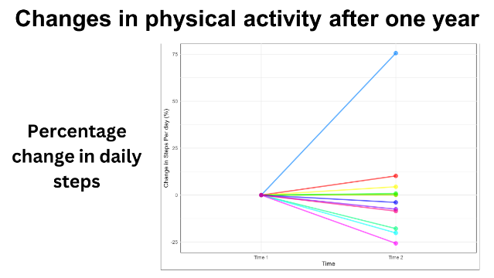
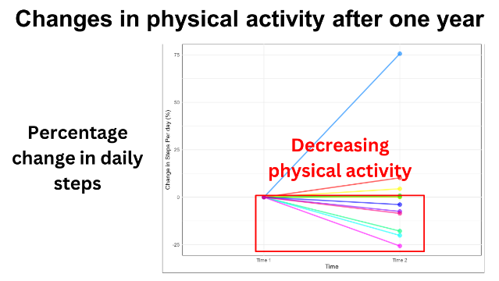
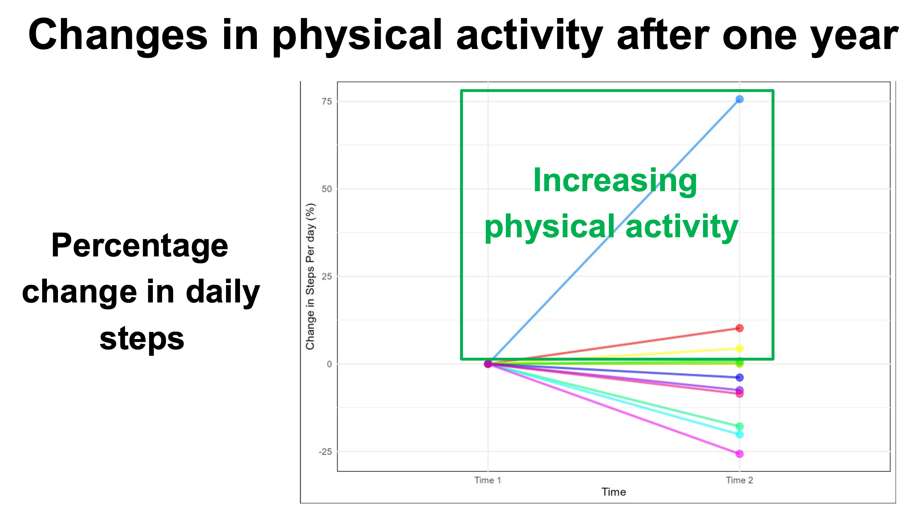
The slides above show the trajectories of change for participants' physical activity at timepoint 1 (baseline) and timepoint 2 (1-year follow-up). The percentages indicate the amount of change between the participants and the changes in their levels of activity between time points. We show the differences in percentages because we may have one participant doing 1,000 steps daily and another doing 10,000 steps daily. If both participants increase their steps by 1,000, participant 1 will double their daily steps ( + 50%), and Participant 2 will increase by 10%.
Within the graph, we can see three separate groups:
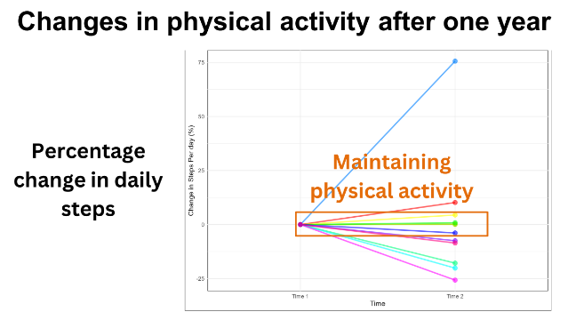
Group 1: people who are increasing their physical activity (steps per day) within the year (from timepoint 1 to timepoint 2) - understandably, we view this increase as very beneficial and would use this group to try to help understand what caused the increase and support this increase in the participant and others.
Group 2: participants who maintained their physical activity (steps per day) within the year - again, this is an excellent result for people living with dementia, and it is essential to understand that maintenance is still an awe-inspiring result for this cohort
Group 3: Participants whose physical activity (steps per day) is declining within the year (from timepoint 1 to timepoint 2)—for this group, we want to understand what causes this loss of PA and see if there is any common ground between participants whose activity declines to help increase PA or reduce barriers.
To unpick this a bit more, what we are seeing is that dementia alone is unlikely to be the sole driving force in the reduction of physical activity. We want to understand better the actual driving forces behind this increase, decrease, or maintenance of physical activity to understand physical activity in Dementia better and improve post-diagnostic care. This should help support the development of a more holistic and personalised support plan for PLWD after diagnosis.
People with dementia can be physically active and will benefit from staying active. Staying active is associated with people's well-being and social support, not just features of their dementia. However, more work needs to be done to translate this data into meaningful changes in dementia care. We aim to include at least 175 people within the project and follow up with as many as possible. We need to understand physical activity with PLWD better to improve their post-diagnostic care. We also need to know why people with dementia increase, maintain or decrease their physical activity over time. By understanding this process, we can change how we think about dementia and physical activity levels, leading to changes in the clinical guidelines. Understanding activity levels can support the development of holistic and personalised support plans for physical activity after a dementia diagnosis.
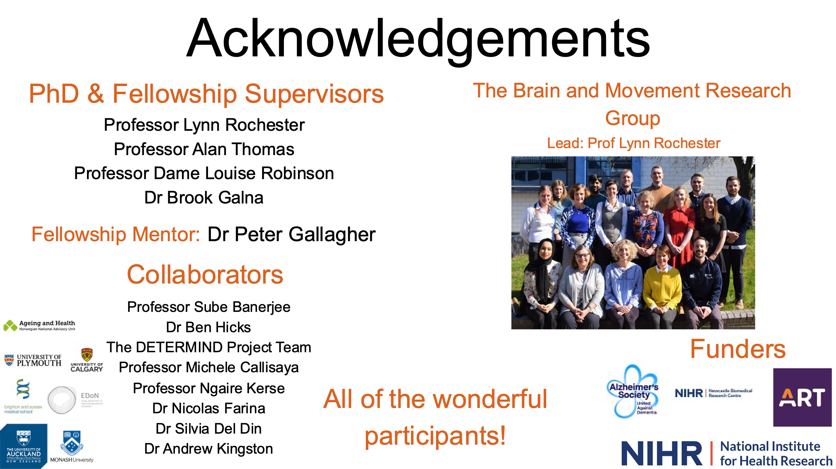

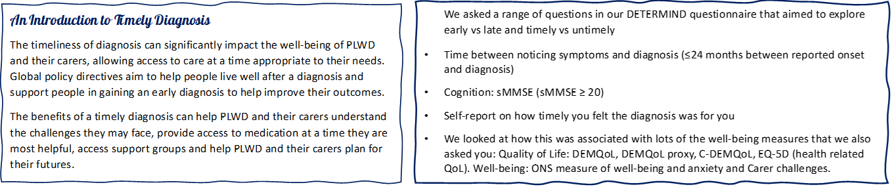
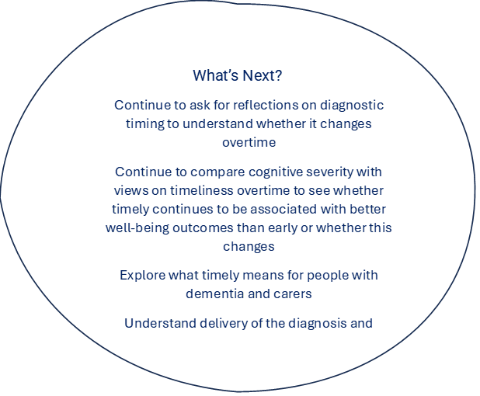
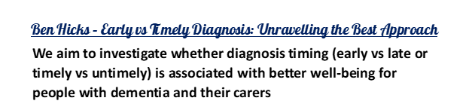
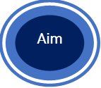
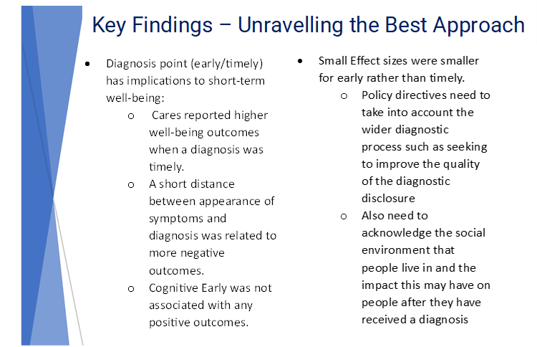


Ben Hicks – Early vs Timely Diagnosis: Unravelling the Best Approach
Citing Paper: Against the stream: early diagnosis of dementia, is it so desirable? Carole Brayne and Sarah Kelly.

An Introduction to Timely Diagnosis
Global policy directives aim to help people live well after a diagnosis and support people in gaining an early or timely diagnosis to help improve their outcomes. The benefits of a timely diagnosis can help PLWD and their carers understand the challenges they may face, provide access to medication at a time they are most helpful, access support groups and help PLWD and their carers plan for their futures. However, stigmatisation of dementia can mean that people often struggle to come to terms with their diagnosis, isolating them from the support of their friends and family and may have practical implications on the independence of the PLWD, such as the loss of their driving licence. Limited academic evidence suggests that an early diagnosis can be good, supporting PLWD to come to terms with the diagnosis long before they may need any interventions.
Our current understanding suggests that a diagnosis can either be early or timely. An early diagnosis is associated with the cognitive severity of the condition at the time of diagnosis. A diagnosis is made in response to the earliest onset of symptoms. A timely diagnosis is a more person-centred approach where the diagnosis is delivered at a time which is best for the PLWD and their family regardless of when the symptoms first began. For those diagnosed with dementia, implementing an earlier diagnosis would allow for earlier treatment of the condition. They suggest that the PLWD and their family could plan more effectively for the future. The current evidence base and limited treatment options do not support early screening of dementia, and we need to understand better the benefits, costs and potential harm to the individuals and services when they are given an early diagnosis. We asked our DETERMIND participants a wide range of questions to explore the impact of early vs late and timely vs untimely diagnosis.

Key Findings
- There was poor agreement between early and timely diagnosis; an early diagnosis does not mean that the diagnosis was timely.
  - Early and Timely diagnosis are two very different aspects of the diagnostic process, and there was no agreement between the PLWD and their carer regarding the timeliness of the diagnosis.
- The point at which a diagnosis is given may have implications for short-term well-being.
  - Higher well-being outcomes were generally better when the diagnosis was timely, especially for the carers.
  - When there was a short distance between noticing symptoms and receiving a diagnosis (early diagnosis), we saw more negative outcomes for the PLWD, suggesting they did not have as much time to prepare for the diagnosis.
  - An early diagnosis was only associated with minimal positive outcomes at the point of diagnosis.
Timely Diagnosis and the DETERMIND Project – Future Direction
The DETERMIND project aims to continually ask our participants to reflect on their diagnostic process to see if this changes over time. By comparing your cognitive sensitivity over time, we can assess whether a timely or early diagnosis is better associated with positive well-being outcomes and whether this changes over time. By exploring what timeliness means to PLWS and their carers, we can understand the delivery process of a diagnosis and its associations with well-being to identify whether an early or timely diagnosis creates inequalities within healthcare provision.

